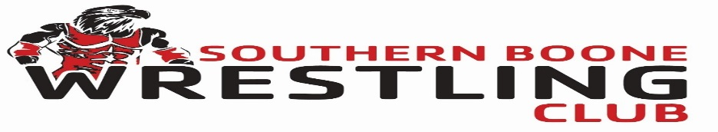
Date/Time: Saturday, July 24, 2021 @ 9am
Location: Southern Boone Area YMCA
405 S. Main Street
Ashland, Mo 65010

Weigh Ins: Saturday 7:00am-8:00am

Entry Fee: $20.00
Registration deadline: July 19, 2021
Admission: $3.00 for adults, $2.00 for students, children under 5 are free
Concessions: Limited concessions available.
Format: Round Robin brackets using USA Wrestling weights and division. We reserve the right to combine weights.
8 & UNDER
40-45-50-55-60-65-70-75-80-85-90-100-115-130-145+
10 & UNDER
50-55-60-65-70-75-80-85-90-95-100-110-120-130-150-170-190-210+
12 & UNDER
60-65-70-75-80-85-90-95-100-105-110-115-120-125-130-135-140-150-165-175-185-210-250+
14 & UNDER
70-75-80-85-90-95-100-105-110-115-120-125-130-135-140-145-150-155-165-175-190-205-235-285

REGISTRATION: Registration is through www.trackwrestling.com
Search Southern Boone Eagle Classic Wrestling Tournament
Press control and click

Contact info: SoBowrestlingclub@gmail.com
Steve Wilmoth: 573-999-3399
