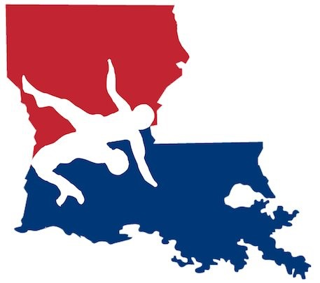
2021 LAUSA State Freestyle & Greco Roman Championships

Date: May 15, 2021

Location: East Ascension High School
612 East Worthey Street
Gonzales, LA 70737

Schedule: Friday, May 14
6:00 to 10:00 PM - weigh ins

Saturday, May 15
7:00 am - doors open
7:30 – 8:30 - weigh-ins
9:00 - Freestyle begins and will continue until completed.
Greco-Roman will begin upon the completion of Freestyle

Divisions: Boys’ Freestyle, Girls’ Freestyle, Open Freestyle, Boys’ Greco-Roman, Open Greco-Roman
A young lady can only be entered in EITHER Boys’ Freestyle or Girls’ Freestyle. She cannot double enter.

Entries: Fee: 30.00 per wrestler (this covers both Freestyle and Greco-Roman)
Deadline for entry 8:00pm May 14, 2021
Awards: Every weight class in every division will receive a champion’s hoodie
Red for Freestyle, Blue for Greco Roman, Pink for Girls Freestyle
Medals for top three placers in each weight class

Tickets: General Admission: 10.00 Under 5 years gets in free

https://www.ticketsource.us/baton-rouge-area-wrestlers-league
DUE TO COVID 19 RESTRICTIONS THERE WILL BE A LIMITED NUMBER OF TICKETS SOLD
T-shirts: T-shirts are $15.00 and can be purchased online through the same link used for buying tickets
FRONT BACK

Concessions: Drinks, snacks, and hot food items will be sold.

For more info contact: Patrick Mahoney (225)954-7804 patrickmahoney@apsb.org

***MASKS ARE REQUIRED AT ALL TIMES FOR SPECTATORS AND
COACHES. WRESTLERS ARE REQUIRED TO WEAR A MASK WHILE NOT ACTIVELY COMPETING. ***

