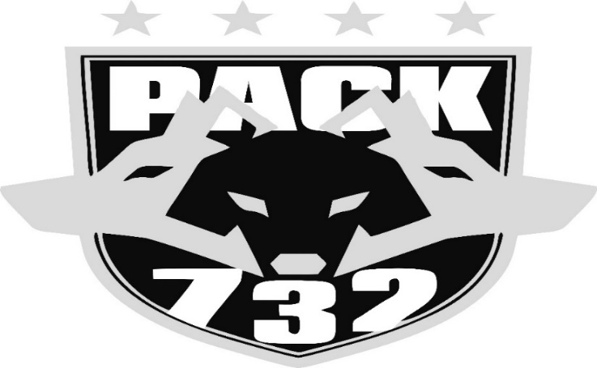
2021-22 PACK732 PROSPECT WRESTLING CAMP
HOSTED BY PACK732 WRESTLING ACADEMY
1120 WEST FIFTH STREET WILTON, IA
Pre-Register online only: http://www.trackwrestling.com/registration/TW_Register.jsp?tournamentGroupId=196143132

$20 Fee (collected First Day of camp at check in) - Includes Camp T-shirt
(Must be registered and paid on August 3rd to guarantee t-shirt)

Check in Date & Time: Tuesday August 3rd 5:30-6pm
Camp Dates:
- Tuesday August 3rd 6-7:30pm
- Wednesday August 4th 6-7:30pm
- Thursday August 5th 6-7:30pm
- Saturday August 7th 9-10:30am

Pack732 Camp Age Levels: Grades 1st- 8th grade for upcoming fall school year. Any Kindergartener must be pre-approved. All those participating must be able to pay attention and follow instructions of the coaches/clinicians. Practices will be conducted in High Pace atmosphere with Repetition and mastery as the focus.

Objective: The camp is designed to teach the basics of Pack732 Wrestling Academy. For current and past members, this camp will be used to advance on previous skills taught. For new members/ prospects, this camp will be used to teach basic skills applied here at Pack732 Wrestling Academy along with giving everyone an insight to the daily practices offered here at Pack732 Wrestling Academy.

Questions or Concerns:
Contact: Kevin Brisker
224-213-0758 (leave a message if not answered and will return call)
Email: 237kcapflow@gmail.com
Please include parent name & phone number and wrestlers name & grade

Check out more information on our Webpage: www.pack732.com

