MISSOURI USA WRESTLING 2021 GIRLS FREESTYLE STATE TOURNAMENT

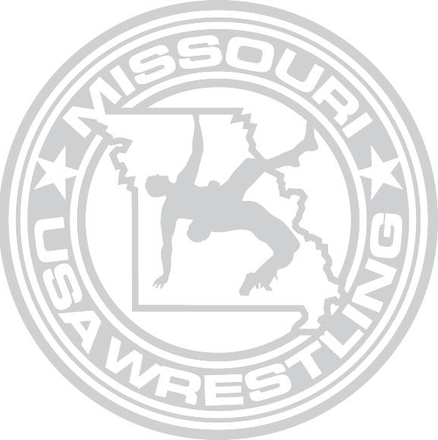

DATE: Freestyle Sunday, April 25th 2021
LOCATION: Missouri State Fairgrounds

Mathewson Exhibition Center 2503 W. 16th St.
Sedalia MO 65301

REGISTRATION: You can register at www.trackwrestling.com

Online Registration will close on Thursday April 22nd 2021 at midnight (cst).
ALL WRESTLERS ARE ENCOURAGED TO REGISTER ONLINE.

ONLY SCHOOLBOY AGE WRESTLERS WILL BE ALLOWED TO COMPETE IN BOTH SATURDAYS STATE TOURNAMENT AND SUNDAYS GIRLS STATE TOURNMENT. IF COMPETING IN BOTH, YOU WILL NEED TO REGISTER IN BOTH TOURNAMENTS. HIGH SCHOOL CAN ONLY COMPETE IN SUNDAYS GIRLS STATE TOURNAMENT.

ENTRY FEE: Online Entry fee will be $25
Onsite Registration Will be available during weigh-ins with an increased fee of $35

Note All wrestlers, who have not registered via trackwrestling.com will be required to present a current USA WRESTLING Competitor’s card at weigh ins. Cards will be available for sale at the tournament. Coaches must have a current Bronze Level Coach’s Card in order to coach at mat side.

TOURNAMENT DIRECTOR: Pat Ream

Pat.ream@mt.com
Contact number 314.479.8014

WEIGH-INS: Saturday April 24th 5:00pm-6:00PM
Sunday April 25th 7:00-8:00a.m

Missouri State Fairgrounds Mathewson Exhibition Center 2503 W. 16th St.
Sedalia MO 65301

Please Note: No wrestler will be allowed to compete with any skin condition without a doctor’s clearance on the standard form. The note must be signed by a doctor and cannot be more than 14 days old.
WRESTLING START TIMES
April 25th 2021 9:00 a.m. to Completion

ADDITIONAL TOURNAMENT INFORMATION
ADMISSION: Admission will be Free of Charge , there will not be an Admission Charge for this Event
COACHING: Only coaches presenting a Valid 2020-21 USA WRESTLING Coaches Coaching Card and that have a Bronze Level Certification will be permitted to Coach mat side. All Coaches will also be required to present a Picture ID in order to be permitted to coach mat side. All Coaches must wear their credentials around their neck while coaching mat side. Any Coach not able to produce proper documentation will not be allowed to coach mat side. MOUSAW has the right to restrict floor access. Coaches Cards are NOT Floor Passes.
WEIGHT CLASSES

High School (BORN 2006 or prior and still in High School)
100-106-112-117-122-127-132-138-144-152-164-180-200-225

KIDS II (BORN 2007-2010)
There will be no set weight classes in Kids II division; the wrestlers will be grouped into brackets according to their actual weights.

KIDS I (BORN 2011-2014)
There will be no set weight classes in the Kids I division; the wrestlers will be grouped into brackets according to their actual weights. Missouri USA Wrestling reserves the rights to combine weight brackets and assign wrestlers into brackets at their discretion. Wrestler’s born after 2014 will not be allowed to register.

All wrestlers will be required to wear their singlet with a sports bra, or other suitable undergarment. There will be no running, or other weight loss measures, allowed inside the wrestling facility.

Girls National Dual Team

THIS WILL BE THE ONLY QUALIFER FOR GIRLS NATIONAL DUALS. TOP 2 AT EACH WEIGHT WILL BE THE ONLY ONES GUARANTEED SPOTS ON THE DUAL TEAM.

Girls Fargo Team

Attending 2021 MOUSAW Girls Freestyle State is mandatory to qualify for Fargo.

Top 4 in each weight class will automatically qualify for Fargo for the weight class they placed top 4 in.

The tournament will be governed by the Missouri USA Wrestling tournament committee and the tournament guidebook.

