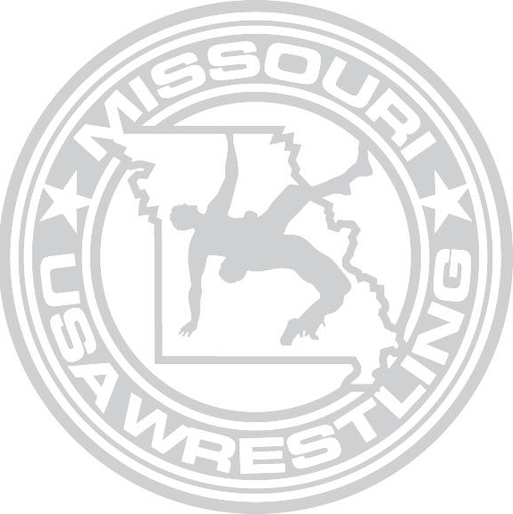
MISSOURI USA WRESTLING 2021 FREESTYLE & GRECO STATE TOURNAMENT

DATE: Freestyle Saturday, April 24th, 2021 Greco Sunday April 25th , 2021

LOCATION: Missouri State Fairgrounds

Mathewson Exhibition Center 2503 W. 16th St.
Sedalia MO 65301

REGISTRATION: You can register at www.trackwrestling.com

Online Registration will close on Thursday, April 22nd at midnight (cst).
ALL WRESTLERS ARE ENCOURAGED TO REGISTER ONLINE.

ENTRY FEE: Online Entry fee will be $25 per style, or $40 for both styles online (non-refundable) Onsite Registration Will be available during weigh-ins with an increased fee of $35
per style, or $50 for both.

Note All wrestlers, who have not registered via trackwrestling.com will be required to present a current USA WRESTLING Competitor’s card at weigh ins. Coaches must have a current Bronze Level Coach’s Card in order to coach at mat side.

TOURNAMENT DIRECTOR: Pat Ream

pat.ream@mt.com
Contact number 314.479.8014

WEIGH-INS: Friday, April 23rd, 2021 Time: 7:00-8:00p.m.

Saturday April 24th, 2021 Time: 7:00-8:00a.m.
Kids & Schoolboys: Additional Weigh-In Saturday April 24th Time: 12:00-1:00 p.m. Greco Only Sunday April 25th 7:00-8:00a.m. (if wrestling both styles you will only be required to weigh-in once)

Missouri State Fairgrounds Mathewson Exhibition Center 2503 W. 16th St.
Sedalia MO 65301

Please Note: No wrestler will be allowed to compete with any skin condition without a doctor’s clearance on the standard form. The note must be signed by a doctor and cannot be more than 14 days old.

WRESTLING START TIMES

Freestyle April 24th Greco April 25th
Juniors & Cadets Start Time 9:00 a.m. to Completion Schoolboys & Kids Start Time Approximately 2:00 p.m.

All Wrestling Will Start at 9:00 am

ADDITIONAL TOURNAMENT INFORMATION

ADMISSION: Admission will be Free of Charge; there will not be an Admission Charge for this Event

COACHING
Only coaches presenting a Valid 2020-21 USA WRESTLING Coaches Coaching Card and that have a Bronze Level Certification will be permitted to Coach mat side. All Coaches will also be required to present a Picture ID in order to be permitted to coach mat side. All Coaches must wear their credentials around their neck while coaching mat side. Any Coach not able to produce proper documentation will not be allowed to coach mat side. MOUSAW has the right to restrict floor access. Coaches Cards are NOT Floor Passes.

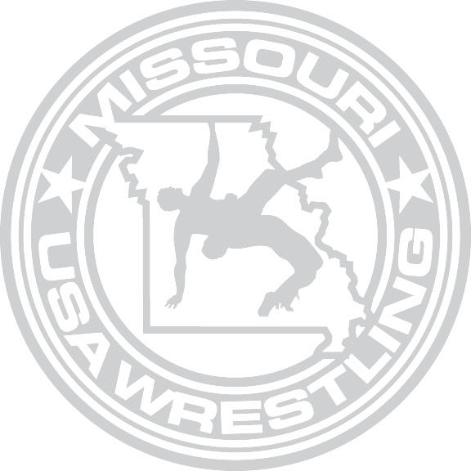

WEIGHT CLASSES

Juniors (Born 9/1/01 and after and in H.S.)
100, 106, 113, 120, 126, 132, 138, 145, 152, 160, 170, 182, 195, 220, 285

CADETS (BORN 2005-2006)
88, 94, 100, 106, 113, 120, 126, 132, 138, 145, 152, 160, 170, 182, 195, 220, 285

SCHOOLBOYS (BORN 2007-2008)
71, 77, 83, 87, 90, 97, 102, 106, 110, 114, 119, 125, 130, 136, 149,165, 187, 250

NOVICE (BORN 2009-2010), AND INTERMEDIATE (BORN 2011-2012).
There will be no set weight classes in the novice and the intermediate divisions; the wrestlers will be grouped into brackets according to their actual weights. Missouri USA Wrestling reserves the rights to combine weight brackets and assign wrestlers into brackets at their discretion. Wrestler’s born after 2012 will not be allowed to register.

Wrestlers will be allowed to weigh-in one time only on Friday night. If a wrestler is over-weight on Friday, they will be allowed to weigh-in one time only on Saturday morning. Wrestlers must be allowed to use any of the certified scales being used for the competition weigh-ins. Wrestlers who are overweight after their one time weigh-in on Sunday morning will not be allowed to wrestle. There will be no running, or other weight loss measures, allowed inside the wrestling facility.

All wrestlers will be required to weigh-in wearing only a singlet with the straps pulled down; females will be required to wear their singlet with a sports bra, or other suitable undergarment

The tournament will be governed by the Missouri USA Wrestling tournament committee and the tournament guidebook.

