2021 TMS Freestyle/Greco Tournament
4/17/2021
@Seckman High School
2800 Seckman Rd
Imperial, Mo 63052

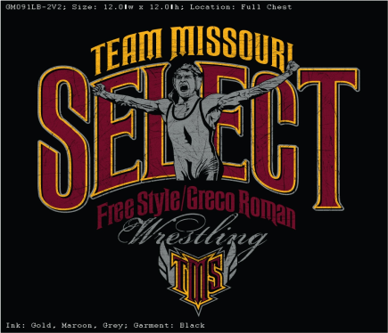

Start Times:
7:30 a.m. Weigh-ins for unattached wrestlers only. Must weigh in before 8:00 a.m.
If your coach e-mails in your weight, you do not have to weigh in.
8:30 a.m. Rules clinic and demonstration
9:00 a.m. Wrestling begins.

MASK MUST BE WORN AT ALL TIMES EXCEPT WHEN WARMING UP OR WRESTLING!

Weight Classes:
Elementary, Middle School, High School, Girls: Grouped into pools of four or five.
We will make every attempt to group wrestlers based upon age and ability level.
The divisions will be dependent upon weight; if there is too much weight difference we will have more groups with fewer competitors in each group.

Entry Fee:
~$30.00 / $45.00 for Both Styles
~Sanctioned by USA wrestling and accident coverage by the same. Everyone must have a USA card to wrestle.
~Checks made payable to SSWC

Preregistration (individual or team lineup)
Teams: Club coaches are responsible for weighing in and sending in rosters.
Individuals: If you are not with a club, you must send in your names and weight in by the deadline. You will need to weigh in at 8 a.m.
All wrestlers must be preregistered by midnight, Thursday, April 15. Club coaches are responsible for collecting payment and submitting one check for their wrestlers. Please e-mail registrations in the Excel format below to: moyerr@foxc6.org

Please use the following format
Last Name | First Name | Division  HS/MS/E/G | Club | Weight | USA Card # | Rating  (1-4)

Weigh-ins
Club coaches should e-mail weights with roster. Only individual entrants must weigh in.

------------------------------------------- Entry Form -----------------------------------------------

Name: _______________________ Weight:_____________

Rating: Circle One

1 State Placer 2 Varsity Wrestler

3 Experienced wrestler 4 Beginner

Age Group: Circle One

Elementary Middle School Girls High School

I want to wrestle (mark with an X) Freestyle:_______Greco:_______ Both:_______

- Please make checks payable to SSWC.

Liability Release:
I, the undersigned, individually and as a Parent/guardian __________________________________ (wrestler’s name)
As a minor, ask that he/she be admitted to participate in the above USA wrestling sponsored event. I do hereby agree to release, discharge and hold harmless USA wrestling & Seckman High School, their agents and employees of and from all causes, liabilities, and damages, claims, or demands whatsoever on account of any injury or accident involving the said minor arising out of the minor’s attendance at the sporting event or in the course of competition held in connection with this event.

