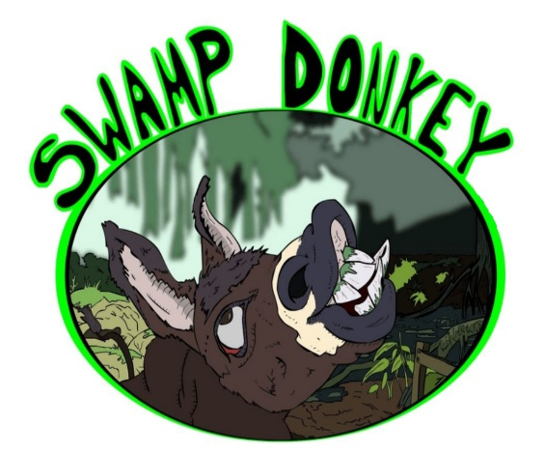
Swamp Donkey
Freestyle / Greco / Folkstyle
Thompson Middle School
100 Warrior Drive
Alabaster, AL 35007

Google Map

Its time to kick off the Freestyle and Greco wrestling season with some action at the Swamp Donkey wrestling tournament. We will also have folkstyle at this event to offer a trifecta of wrestling styles. Can you pull off a tri style championship and earn the coveted Swamp Donkey trophy?

MANDATORY PRE-REGISTRATION
Please note that wrestlers will need their USA Card to pre-register. Tournament Fee is paid online. Each wrestler may compete in one weight class. Any wrestler who fails to pre-register will NOT be able to compete in the tournament.

Registration will cost $20.00 for one style, 5.00 extra for each additional style
Normal Registration DEADLINE: Friday April 9th at 3:00 pm CST
NO ONSITE Registrations

Pre-Register Now!

Weigh-ins
Friday April 9th @ 6:00-8:00 PM
Saturday April 10th @ 8:00-9:00 AM
**** Wrestlers must weigh-in ONCE before they wrestle ****
** Wrestlers may not wrestle in the weight below what they weigh-in at. Actual weight
rounds UP to select a weight class (not the closest weight) during registration.

Spectator Admissions
Over 12 - $10
Under 12 - $5
Under 3 – Free
Coaches - $5
Tournament
Weights will be grouped to get plenty of matches!
Tournament T-Shirts will be available!
Concessions will be available!
Coaches must have a valid USA or AAU Coaches Card!
Coaches will receive wristband for hospitality room!

Age Groups, Weights, & Period Lengths
AGE DIVISIONS | BIRTH DATES | FR/GR MATCH  TIME LIMITS | FOLKSTYLE MATCH  TIME LIMITS | WEIGHT CLASSES
8U | 2013 - 2014 | Two 2-minute  periods w/ 30 second  rest between periods | Championship and Consolation: 3 one-minute periods | 43, 45, 49, 53, 56, 62, 70, 85
10U | 2011-2012 | Two 2-minute  periods w/ 30 second rest between periods | Championship and Consolation: 3 one-minute periods | 49, 53, 56, 59, 63, 67, 71, 77, 84, 93, 105, 120
12U | 2009-2010 | Two 2-minute  periods w/ 30 second rest between periods | Championship: 1 one-minute and 2 1:30 periods; Consolation: 3 one-minute periods | 58, 63, 67, 70, 74, 78, 82, 86, 92, 98, 108, 117, 135, 160
14U | 2007-2008 | Two 2-minute  periods w/ 30 second  rest between periods | Championship: 1 one-minute and 2 1:30 periods; Consolation: 3 one-minute periods | 71, 77, 83, 87, 92, 97, 102, 106, 110, 114, 119, 125, 130, 136, 149, 165, 187, 250
16U | 2005 – 2006 | Two 2-minute  periods w/ 30 second rest between periods | Championship: 3 two-minute periods; Consolation: 1 one minute and 2 two-minute periods | 88, 94, 100, 106, 113, 120, 126, 132, 138, 145, 152, 160, 170, 182, 195, 220, 285
Junior | 2001 – 2004 | Two 3-minute  periods w/ 30 second rest between periods | Championship: 3 two-minute periods; Consolation: 1 one minute and 2 two-minute periods | 100, 106, 113, 120, 126, 132, 138,145, 152, 160, 170, 182, 195, 220, 285

Event Schedule
Friday April 9th
6:00 - 8:00 PM Early Weigh-ins (All Tournaments)
Saturday April 10th
8:00 - 9:00 AM Weigh-ins (All Tournaments)
10:00 AM - 12:30 PM Freestyle Tournament
1:00 PM - 3:00 PM Greco-Roman Tournament
3:30 PM - Finish Folkstyle Tournament
** Awards will be handed out as weight classes are completed (1st-4th) **
*** Trophies will be handed out at the end of Folkstyle for a Tri-Style Champions ***

Tournament Director
Ben Wanagat – ben@tournamenttruck.com

This tournament is brought to you by
