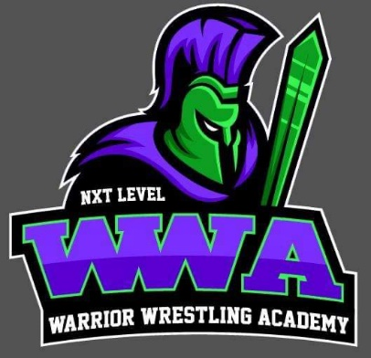
Warrior Open
Saturday, May 22nd
NXT Level Ultimate Sports Complex
865 Suprise Ending, New London, WI 54961
wrestling begins at 9am
NXT Level Ultimate Sports Complex will be hosting the Warrior open Saturday, May 22nd @ the Ultimate Sports Complex in New London. This will be a scramble paired event open to all wrestlers from 9th-12th grade with the goal of getting every wrestler 3 matches.
This is a pre-registration only event on Trackwrestling:
https://www.trackwrestling.com/registration/TW_Register.jsp?tournamentGroupId=195964132
Event Details:
$20 PER WRESTLER
- Folkstyle
- USA Card Required
- $20 per wrestler (pay when you arrive)
- Registration deadline is Wednesday, May 19th @ 10:00pm
- No weigh-in, however, wrestlers cannot be more than two pounds over listed weight
- Trackwrestling’s Scramble Pairings will be used to match Wrestlers based on grade, skill and weight
- Match Length will be 2-2-2 with High School Overtime
- No awards, this is for matches only
- Food and beverages will be available throughout the day
For more information, contact Dom Gunderson at gundersondominic59@gmail.com
REGISTRATIONS DUE MAY 19TH

