KS Heartland Duals Qualifier & 6U State

KANSAS STAR ARENA, Mulvane, KS

MARCH 7th, 2021
KANSAS 6 UNDER
STATE CHAMPIONSHIPS
COME TAKE HOME THE BELT!!!!!
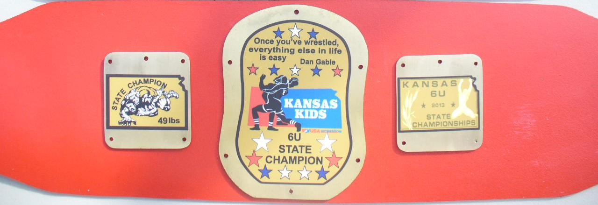
Awards
Champions – Belt, 2nd – 6th Medals
Weight classes
37, 39, 41, 43, 45, 47, 49, 51, 53, 55, 58, 61, 64, 67, 70, 73, 80, 88, 95 & HWT

Qualifying tournament for TEAM KANSAS Elementary, Middle School, and Girls Dual Teams going to Council Bluffs, IA on April 16-18, 2021.

Elementary State Championships
Weight Classes: 50, 55, 60, 65, 70, 75, 80, 85, 90, 95,100, 105, 112, 120, 130, 140 and 160
NO WEIGHT ALLOWANCE WILL BE GIVEN

Middle School Championships
Weight Classes: 75, 80, 85, 90, 95 102, 110, 117, 125, 132, 140, 150, 160, 175, 195, 220 and 275
NO WEIGHT ALLOWANCE WILL BE GIVEN

Girls Championships
Weight Classes: 58, 65, 73, 82, 89, 97, 102, 109, 117, 126, 138, 150 & 165
NO WEIGHT ALLOWANCE WILL BE GIVEN

Enter Fee: $25.00
Enter on TrackWrestling.com.
Enter Deadline is March 3rd at 11:59pm

This will be a spilt tournament.
SUBJECT TO CHANGE
All depends on number of entries.
AM Starting 8:30
Middle School Boys / Girls

PM Starting no earlier than 1:00
Elementary / 6 and Under

Weigh in will be held Friday night at the district weight ins.
The Friday night weigh in will count for the weigh in for Sunday.
District 3 will have a few sites to weigh in.
Salina, Topeka, Manhattan, & Emporia
Contacts:
Middle School/ 6U
James Cook-785-212-0605 jcook@maswu.org
Elementary
Dal Eck- 316-641-4913 dal@matteck.com
Girls
Susan Redman-913-909-1090 redsue5@gmail.com

All Wrestlers must have a USA Wrestling Membership Card
Coaches must have Bronze Card.
KSHSAA rules w/ kids’ modifications.

Cost of Admission.
$8.00

Weigh in District 3 Locations
March 5th

6:00-7:30pm
Topeka YMCA
3635 SW Chelsea Drive
Topeka KS 66614
Contact Mark Stanley 785-224-5161

Emporia
5:30-6:30
24/7 Fitness
622 Merchant St
Emporia
Matt Collins 620-794-2005

Manhattan
5:30-6:30 pm
Kansas National Guard
721 Levee Dr
*Enter side door--follow the sidewalk behind the flag poles. Only athletes will be allowed to enter.
Contact: Brian Nelson 785-477-0786

Salina
5:30-6:30 pm
St. Johns Military School Cafeteria
110 W. Otis Ave.
Contact: Bob Stein
(785) 643-3410

There will be an hour weigh in Saturday night March 6th at the Kansas Star arena.

6:30p-7:30p Weight ins
Enter Upper Level Area and line up around the concourse
Weight ins will be taking place on the Arena floor
1 adult per child please for weight ins

2021 KANSAS DUAL TEAM SIGN UP FORM
Registration Form

Name: _____________________________________________6 DIGIT USA CARD # ___________________

Date of Birth ______________________ 2020-21 Age Class ______________ Weight _____________

Address: _____________________________________________________________________________________

City: ____________________________________________ St _______ Zip ________________

School Attending ___________________________________________________ Grade __________________

Father’s Name _____________________________________________________________________________

Address: __________________________________________________________________________________

Work/Home Phone ____________________________________Cell Phone____________________________

Email ______________________________________________

Mother’s Name ____________________________________________________________________________

Address: _________________________________________________________________________________

Work/Home Phone______________________________________ Cell Phone __________________________

Email _____________________________________________

EMERGENCY CONTACT INFORMATION:

Name: _______________________________________________________ Phone __________________________

ACCOMPLISHMENTS: ______________________________________________________________________

____________________________________________________________________________________________

KANSAS KIDS DISTRICT: _________ KANSAS KIDS CLUB: _______________________________________

MY WRESTLER - WILL ______WILL NOT ______ BE STAYING/ROOMING WITH THE TEAM

ROOMATE PREFERENCES _______________________________________________________________________

MY WRESTLER - WILL ______ WILL NOT ______ BE MEETING AND RIDING WITH THE TEAM IN TOPEKA

PLEASE BRING WITH YOU TO THE EVENT COPIES OF - Birth certificate, Current Grade Card, and Insurance Card.
TEAM KANSAS CODE OF CONDUCT
- Absolutely no use or possession of alcohol, tobacco, or drugs.
- Team members will not trade team apparel until wrestling has been completed.
- Team members will wear team apparel until wrestling has been completed.
- Theft will not be tolerated! There is no such thing as finders’ keepers. If you find something that isn’t yours we expect you to turn it into a Team Kansas Coach.
- You will be expected to treat the vans, hotel rooms, and wrestling venue with respect. Destruction of property will not be tolerated.
- Team members will stay in their assigned vans and rooms unless your coach has been notified and approves the change.
- Team members will remain in the hotel unless they have permission from a coach to depart to eat.
- Team members will remain on the bench during duals unless they have permission from the bench coach to leave the bench area.
Team Kansas has competed in the Middle School National Duals for many years. We have not had any problems in the past and I don’t anticipate any this year. Should your wrestler violate the code of conduct we will call you and immediately notify you so that we can determine the consequences beyond immediate dismissal from competition.
TEAM KANSAS CODE OF CONDUCT

I ________________________________ Team Kansas Member, agree to the Code of Conduct.
Wrestler’s Signature _________________________________________________

Parent’s Signature ___________________________________________________

