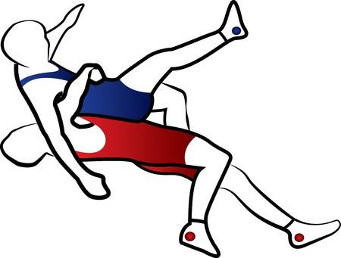

Future Champions Beginner Brawl
Gordon Lee High School
105 Lee and Gordon Mill Circle, Chickamauga, GA 30707
- Date: February, 13 2021
  - Weigh-ins: Honorary Weigh-ins
- Coaches Meeting: 8:15 a.m.
- Skin & Nail Check: Starts at 8 – TOTS; 10- BAN, 12 - JR, 2 - Midget, and 4 - MS
- Wrestling Begins: 8:30 a.m. - TOTs, 10:30 - BAN, 12:30 - JR, 2:30 - Midget, 4:30 - MS

- Registration Cost: $12 per wrestler
- Awards: Place 1st -3rd
- Divisions/Weights: 1st and 2nd year wrestlers only
- Tot Born 2015/after (30,35,40,45,50,55, HWT (90Max)
- Bantam Born 2013/2014 (40,45,50,55,60,65,70,75,80,90, HWT (125 Max)
- Midget Born 2011/2012 (50,55,60,65,70,75,80,85,90,95,103,112,120,130, HWT (175 Max)
- Juniors Born 2009/2010 (60,65,70,75,80,85,90,95,100,105,112,120,130,140, HWT (205 Max)
- Middle School 2006,2007 & 2008 (70,75,80,85,90,95,100,105,110,115,120,125,130,140,150,160,180, HWT (260 Max)

- Gate Cost: $5.00 adults, $3.00 children, 3 and under are free
- We have a max number of people we are allowing in the building, so please be considerate to other fans and not attend until your child’s session is wrestling.
- All fans and wrestlers (when not wrestling, on deck, or in the hole) are asked to wear a mask and stay in bleachers away from the mats.
- Wrestlers are allowed to sign up for multiple divisions but NOT ALLOWED Multiple weights in same division with exception of Middle School.
- 250 max wrestlers
- This event is licensed by the Amateur Athletic Union of the U.S., Inc.
- All participants must have a current AAU membership.
- AAU membership may not be included as part of the entry fee to the event.
- AAU Youth Athlete membership must be obtained before the competition begins, except where the event operator has a laptop available with an internet connection.
Be Prepared: Adult and Non-Athlete memberships are no longer instant and cannot be applied for at an event.
Due to background screenings, please allow up to 10 days for adult memberships to be processed.
- Participants are encouraged to visit the AAU website www.aausports.org to obtain their membership.

For more information call Dusty Brown (606) 521-0923 or Heith Saine (423)313-5231

