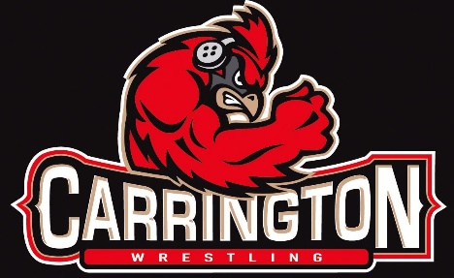

Carrington Pit Crew Kids Wrestling Tournament
Sunday, February 28th, 2021

Site: Carrington Public School – South Entrance (wrestling in 2 gyms)

Weigh-Ins: Conducted at home

Pre-Registration: Trackwrestling ONLY – Deadline Friday, February 26th 10pm - Limit 250 per session

http://www.trackwrestling.com/registration/TW_Register.jsp?tournamentGroupId=193466132

Sessions: Pre-K thru 2nd Grade 3rd Grade thru 8th Grade
Check-In: 9:00-10:00 Check-In: 11:30-12:30
Starting Time: 10:30am Starting: 1:00pm

Entry Fee: $12.00
Pairings: Participants will be grouped as close as possible to actual weights in these groups: Pre/K, 1st/2nd graders, 3rd/4th graders, 5th/6th graders and 7th/8th graders. We will be trying to use round robin groups of 4 and 5.

Rules: Folkstyle rules with three periods: 1:00, 1:30, 1:30 min.

Awards: Trophies 1st
Medals for all others

Contact Dennis Freeman H 652-3628 Cell 307-0432 Freeman11@daktel.com

.....................................................................................................................................................

Concessions Available by the Carrington Wrestling Club

COVID-19 Precautions: Masks ARE REQUIRED for all spectators, and wrestlers when not wrestling. We encourage everyone to social distance as they can. Please try and limit the number of spectators to 2 per wrestler. We will monitor facility occupancy limits during the tournament. IF YOU OR YOUR ATHLETE ARE NOT FEELING WELL PLEASE REFRAIN FROM ATTENDING.

PLEASE CHECK THE DAKOTA GRAPPLER OR CALL IF INCLEMENT WEATHER FOR CANCELLATION

