MISSOURI USA WRESTLING 2021 ROOKIE STATE TOURNAMENT
INFORMATION SHEET

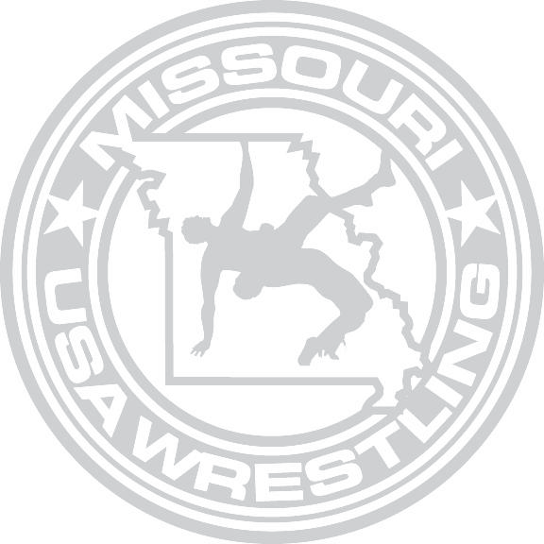
DATE: Saturday, January 23rd, 2021

LOCATION: Missouri State Fairgrounds

Mathewson Exhibition Center 2503 W. 16th St.
Sedalia MO 65301

REGISTRATION: You must register at: https://www.trackwrestling.com/tw/opentournaments/VerifyPassword.jsp?tournamentId=617956132

2021 MO/USA Rookie State Tournament

There will be no walk-in registration!
Registration will close on Wednesday January 20th at 10:00 PM

ENTRY FEE: $35.00, non-refundable, must accompany entries.

TOURNAMENT DIRECTOR: Erik Kivett

ekivett4@gmail.com

(417) 658-9007

OFFICIALS: All officials will be MSHSAA certified.

WEIGH-INS: Friday, January 22nd Time: 6:30-7:00 p.m.

Missouri State Fairgrounds Mathewson Exhibition Center 2503 W. 16th St.
Sedalia MO 65301
Optional Weigh-in Locations: No Optional Remote Weigh-ins

Saturday, January 23rd Missouri State Fairgrounds Mathewson Exhibition Center 2503 W. 16th St.
Sedalia MO 65301
8U and 14U-Time: 7:00 a.m.-7:30 a.m.
10U and 12U- Time: 12:30 p.m.-1:00 p.m.

COACHES MEETING:

WRESTLING BEGINS:

8:00 am
Only coaches presenting a valid 2020-21 USA WRESTLING Leader membership card, with a current profile picture on it, and a minimum of bronze certification will be issued coaching credentials and allowed to coach at matside. The tournament host has the right to restrict floor access. Coaches Cards are not considered floor passes. Coach’s with a Valid Coaching Card & Bronze Certification must wear their credentials around their neck and have a valid issued coaching band to be matside. Any coach unable to produce both will not be allowed to coach matside or be allowed on the floor.

8U and 14U 8:30am
10U and 12U 2:00pm

TOURNAMENT FORMAT: This will be a double elimination tournament. There will be no combining of brackets. There could be an A, B, C; etc. brackets in those age/weight classes in which there are more than 16 wrestlers. Five man and less person brackets will be wrestled as round robins. SPLIT SESSION- 8U AND 14U in the AM, 10U AND 12U IN THE PM
GATE ADMISSION: Admission will be Free of Charge, there will Not be an Admission Charge for this Event

Match Times: 8 3-1 minute periods
10, 12 & 14 3-1:30 minute periods, backside 1:00, 1:30, 1:30
Overtime: Same as high-school rule book

WEIGHT CLASSES

8 & UNDER
40-45-50-55-60-65-70-75-80-85-90-100-115-130-145+
10 & UNDER
50-55-60-65-70-75-80-85-90-95-100-110-120-130-150-170-190-210+

12 & UNDER
60-65-70-75-80-85-90-95-100-105-110-115-120-125-130-135-140-150-165-175-185-210-250+

14 & UNDER
70-75-80-85-90-95-100-105-110-115-120-125-130-135-140-145-150-155-165-175-190-205-235-285

NO TEAM SCORES WILL BE KEPT.

Rookies are first year wrestlers only! This event is for first time card members of any wrestling organization that are currently members of Missouri USA Wrestling.

All participants will compete at the age they were on December 31st, 2020. No high school students, regardless of their age, and no out-of-state residents, even if they are members of a MISSOURI USA WRESTLING chartered club. 15 year olds may participate only if they have not reached 15 before January 1st, 2021 and are not in high school.

Scratch Weight. All Wrestlers must make Scratch Weight

Wrestlers will be allowed to weigh-in one time only on Friday night. If a wrestler is over-weight on Friday, they will be allowed to weigh-in one time only on Saturday afternoon. Wrestlers must be allowed to use any of the certified scales being used for the competition weigh-ins. Only tournament personal will be allowed in the weigh in area, once weigh-ins begin. There will be no running, or other weight loss measures, allowed inside the wrestling facility.

All wrestlers will be required to weigh-in wearing only a singlet with the straps pulled down; females will be required to wear their singlet with a sports bra, or other suitable undergarment. Each wrestler will be visually checked and if a participant is suspected of having a communicable skin disease, or any other condition that may make participation inadvisable, the wrestler must provide written documentation (which must be on the form supplied by MISSOURI USA WRESTLING and obtained by the participants club), dated and signed by a physician, within 14 days of the tournament, stating that the suspected disease or condition is not communicable and that the athlete’s participation would not be harmful to their opponent. They must also have attached a doctor’s letterhead or a sheet from the doctor’s prescription pad to the skin form.
This document must be furnished at weigh-ins. Covering a communicable condition shall not be considered acceptable and does not make the wrestler eligible to participate.

All suspected skin conditions must be covered at all times while the competitor is on the mat. Further, that in the event said skin condition is not covered, becomes uncovered or is not coverable, then the competitor may be required to forfeit, at the discretion of the tournament director or host official. If a wrestler shows up to wrestle without the condition covered, the wrestler will be put on one of their injury time-outs to correct the situation.

BRACKETING – General
- All brackets will be completed via a blind draw based on the number entries per age/weight class, except for separating wrestlers from the same team.
- All brackets are double elimination, with the exception of brackets of five or less, where each entrant wrestles the other wrestlers in the bracket (round-robin).

SEEDING – There will be no seeding. If two wrestlers from the same club appear at the same weight, each wrestler shall be drawn into the bracket; however, they must be in opposite halves of the bracket. If three or more wrestlers from the same club appear at the same weight, each wrestler shall be drawn into the bracket, however that they must be in different quarters of the bracket, as long as this is possible. Byes shall be drawn into the bracket before. When two or more byes occur in a bracket, an equal number of byes shall be drawn into each half of the bracket.

The tournament will be governed by the Missouri USA Wrestling tournament committee and the tournament guidebook.

Mask will be required: Following Covid guidelines from the county.
https://pettiscountyhealthcenter.files.wordpress.com/2020/08/8-6-2020rule-signed.pdf

