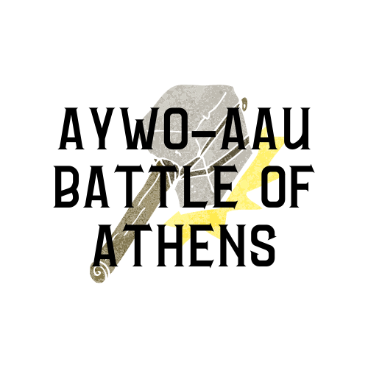

**January 23rd, 2021**

**Athens High School Arena**

655 US-31 N Athens, AL 35611

[Google Map](https://www.google.com/maps/place/655+US-31,+Athens,+AL+35611/data=!4m2!3m1!1s0x88628b2f820b69e7:0xf85e8f5e28cf5472?sa=X&ved=2ahUKEwj_gPOPgOzsAhWbbc0KHbn9DhQQ8gEwAHoECAsQAQ)

***Tot and Bantam will have 2 random weight class weigh ins***

Satellite weigh in locations located under On-site weigh ins

You have the Rudis Sword, Shield, Helmet and the Trident. Complete your battle gear with the War Hammer! This week’s coliseum battle takes place in Athens, AL. Come out to showcase your engrained wrestling skills that you have been working on since November.

This week the best of the best will be awarded with a custom engraved War Hammer to the Outstanding Wrestlers and Most Valuable Wrestler in each age division. The war hammer was created to deliver a full force blow and overtake the opponents that were wearing hardened steel armor. Much like Thor’s hammer, Mjolnir, only the worthiest of warriors can wield its mighty force. If you’re ready for the fiercest competition in the state, bring your inner warrior and compete for the War Hammer.

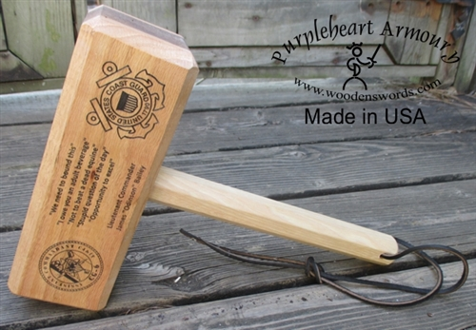

**Criteria for Most Valuable Wrestler / Most** **Points**: *Advanced brackets only* Most amount of team points for the tourney and must be champion of their bracket.

In the event of a tie on number of points the wrestler with the most pins, tech fall or major decisions wins.

**Criteria for Most Outstanding Wrestler / Most Pins**: *Advanced brackets only* Most number of pins and must be champion of their bracket.

In the event of a tie on number of pins the wrestler with the least amount of time on the mat will be selected.

*The same wrestler will not be eligible to win both awards*

*A wrestler is only eligible to win one award per event*

**MANDATORY PRE-REGISTRATION**

Please note that wrestlers will need their [AAU Card](https://play.aausports.org/AccountRegistration.aspx) and [Trackwrestling](http://tw01.trackwrestling.com/tw/membership/TWRegistration.jsp?TIM=885680&twSessionId=awslnpundlkogdm&fromDomain=1.0E-5) number to pre-register. Tournament Fee is paid

online. **Each wrestler may compete in one weight class in two age divisions**. When pre-registering, each wrestler is required to select a skill level. There will no longer be beginners brackets. Any wrestler who fails to pre-register will **NOT** be able to compete in the tournament.

Registration will cost $15.00. Late registration will cost $20.00.

Normal Registration DEADLINE: Friday January 22nd at 9:00 am CST

Late Registration: 9:01am to 12:00 pm CST

[Pre-Register Now!](http://www.trackwrestling.com/registration/TW_Register.jsp?tournamentGroupId=193309132)

**SATELLITE WEIGH-IN**

**NOTE:** Only Tot and Bantam divisions will satellite weigh in. TOT and Bantam wrestlers DO NOT receive a 1 lbs allowance. We encourage and fully expect our coaches and club representatives to demonstrate integrity in the weigh-in process.  Each Club will weigh in their wrestlers on Thursday night after practice or by Friday before the 12:00 pm deadline. The Wrestler’s weight will be written on his left arm by a coach or club representative. This year coaches will validate their own tot and bantam wrestlers’ weights. Once registration closes the tournament will be open for coaches see their wrestlers. If a tot or bantam is not in the correct weight class, the coach will email the tournament host and tournament operations director with the wrestlers name, team and correct weight class. Note: Please review the AAU policy on satellite weigh-in as well as the rules pertaining to growth allowance and challenge procedures.

**ONSITE WEIGH-IN**

Age groups Midget, Novice and Schoolboy will begin 1 hour and 15 min prior to start time of each age division and will end 30 min prior to start time. 1 lbs allowance for onsite weigh ins. Each wrestler must weigh in during their appointed weigh in times. After the weigh in is closed, any wrestler that misses the weigh in can bump up to the next division.

**Friday Night Weigh-Ins for Midget – Schoolboy 6pm – 7 pm CST**

**Region 1 Region 2 Region 3**

Tennessee Valley Wrestling Club Warrior Wrestling Club Swarm Wrestling Club

Bob Jones High School 2469 Hwy 31 9425 Alabama highway 51

650 Hughes Road Madison, AL 35758 Calera, AL 35040 Opelika, Alabama 36804

**Tournament Director**: Andrew Campbell, andrew.campbell@acs-k12.org

**Tournament Operations Director**: Ben Wanagat, [benwanagat@gmail.com](mailto:benwanagat@gmail.com)

**Information**

Wrestlers will not have to wear masks while competing.

Only a single division of spectators and wrestlers are allowed in the gym at one time.

Only coaches and upcoming wrestlers are allowed on the mat. No Exceptions

AYWO Standards will be used for age divisions and weight classes.

The wrestle-back format will be used to determine a true second place finish.

Coaches must maintain a visible **AAU Card** and must **provide proof of the completed CDC Concussion training** to be allowed on the mats and in the hospitality room.

Only two coaches are allowed in the corner during a match.

There are no refunds for this event.

Temperatures will be taken at the door. If anyone's temperature is over 100.3 they will not be permitted to enter the venue

2 warnings will be given to anyone not wearing their mask. On the third time they will have to leave the venue for the rest of the event.

The venue will be cleared out at the end of each division for cleaning.

If a spectator is unable to wear a mask, they will not be allowed to enter the venue for their safety and that of the wrestlers/spectators/coaches and workers.

These are steps AYWO is taking to ensure we are keeping the wrestlers/spectators/coaches and workers as safe as can be done.

Entrance Fees: Adults: $7.00, Kids: $5.00, Under 3 free

**Saturday January 23rd Wrestling Schedule**

**TOT** Division Born 1/1/2014 – 12/31/2016: Wrestling begins at 9:00 am – 11:00 am

35, 40, 45, 50, 55, 60, 65, 65+

**BANTAM** Division Born 1/1/2012 – 12/31/2013: Wrestling begins at 11:15 am – 1:15 pm

40, 45, 50, 55, 60, 65, 70, 75, 80, 90, 105, 105+

**MIDGET** Division Born 1/1/2010 – 12/31/2011: Wrestling begins at 1:30 pm – 3:30 pm

Weigh in: 12:15 am to 1:00 pm.

50, 55, 60, 65, 70, 75, 80, 85, 90, 95, 103, 112, 120, 130, 130+

**NOVICE** Division Born 1/1/2008 – 12/31/2009: Wrestling begins at 3:45 pm – finish

Weigh in: 2:30 pm to 3:15 pm

60, 65, 70, 75, 80, 85, 90, 95, 100, 105, 112, 120, 130, 140, 140+

**SCHOOLBOY** Division Born 1/1/2006 – 12/31/2007: Wrestling begins at 3:45 pm – finish

Weigh in: 2:30 pm to 3:15 pm

70, 75, 80, 85, 90, 95, 100, 105, 110, 115, 120, 125, 130, 135,140,145, 120, 160,171, 189, 220,250

************************************************************************************************************

This event is licensed by the Amateur Athletic Union of the U.S.,Inc.

All participants must have a current AAU membership.

AAU membership may not be included as part of the entry fee to the event.

AAU Youth Athlete membership must be obtained before the competition begins.

BE PREPARED!

Adult and Non Athlete memberships are no longer instant and cannot be applied for at event.

Please allow at least 10 days for membership to be processed.

Participants are encouraged to visit the AAU website www.aausports.org to obtain their membership.