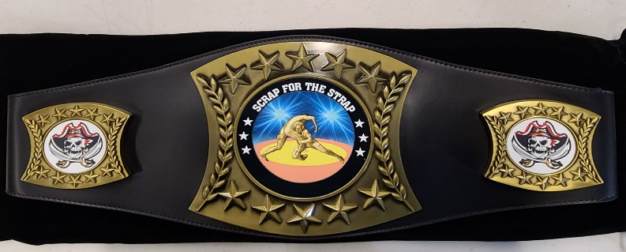
2
nd
Annual
Hannibal Wrestling Club

Date:

Saturday, January 2-3, 2020

Where: |  | Hannibal Old Armory  301 Warren Barrett Drive  Hannibal, MO 63401
Entry Fee: |  | $40 per wrestler (LIMITED TO FIRST 900)  Register via Track Wrestling at www.trackwrestling.com  REGISTRATION DEADLINE: Midnight on 12/29/2020
 |  | NO ONSITE REGISTRATIONS OR REFUNDS
Format: |  | SPLIT SESSION FORMAT  Session 1 - 1/2/2021 - 6U/8U/10U- Wrestling begins at 9:00am sharp.  Session 2 - 1/3/2021 - 12U/14U/Girls- Wrestling begins at 9am sharp.  6U,8U – 1-1-1 format. 10U,12U,14U 1.5-1.5-1.5 format
Weigh-ins: |  | Session 1- Friday, January 1, 2021 6-8pm - Saturday, January 2, 2021 6:30am-8am  Session 2- Saturday, January 2, 2020 5pm -6pm – Sunday, January 3 6:30am-8am
 | **Remote weigh-ins may be granted by calling Tournament Director**

Age & Weight: Wrestler’s Age as of December 31, 2020.

Awards: 1st place winners in each bracket will receive custom belt. 2nd-4th place will receive medals.

Questions: Tournament Director: Lance Gauch
Phone: 573-629-9998 E-mail: wrestlingcoach720@gmail.com

Hotel Information: Comfort Inn and Suites - 4000 Market St, Hannibal, MO 63401
Best Western on the River - 401 N 3rd St, Hannibal, MO 63401

DIVISIONS:
6U: 37, 40, 43, 46, 49, 52, 55, 61, 67, 77, HWT
8U: 40, 43, 46, 49, 52, 58, 64, 72, 85, 95, HWT
10U: 50, 54, 58, 62, 66, 70, 75, 80, 85, 90, 95, 100, 105, 115, HWT
12U: 64, 68, 72, 76, 80, 85, 90, 95, 100, 107, 115, 125, 135, HWT
14U: 75, 80, 85, 90, 95, 101, 108, 115, 122, 129, 136, 143, 150, 170, HWT

Girls
9U: 45, 55, 65, 75, 85, 100, HWT
12U: 55, 65, 75, 85, 95, 105, 120, 135, HWT
14U: 75, 85, 95, 105, 115, 125, 135,145, 155, 175, 215, HWT

**We reserve the right to combine weight classes, if necessary**

Admissions: Adults $3, Kids $2 (Ages 5 & under are FREE)
Concessions will be a food truck that is outside the event

Hannibal High School and Hannibal Wrestling Club will not be responsible for accidents, injuries, and lost or stolen items.

COVID GUIDELINES
- Temperatures will be checked at the door, if you have a fever, you will NOT be permitted.
- Masks will need to be worn at all times,(even wrestlers when they are not on the mat) you will be asked to leave if you do not follow this rule.
- Practice social distancing (6ft) from anyone that does not live in your household.
- Only 2 adults permitted per wrestler, or family of wrestlers, so if a family has 4 kids then both parents of those kids will be the only adults permitted for that family.
- BLEACHER SEATING/CHAIRS WILL BE VERY LIMITED, BRING A LAWN CHAIR TO SIT IN PLEASE.
- COACHES MUST HAVE COACHING CREDITIALS SHOWING TO BE MATSIDE AT ALL TIMES

