June 15th – 19th OR July 20th – 24th 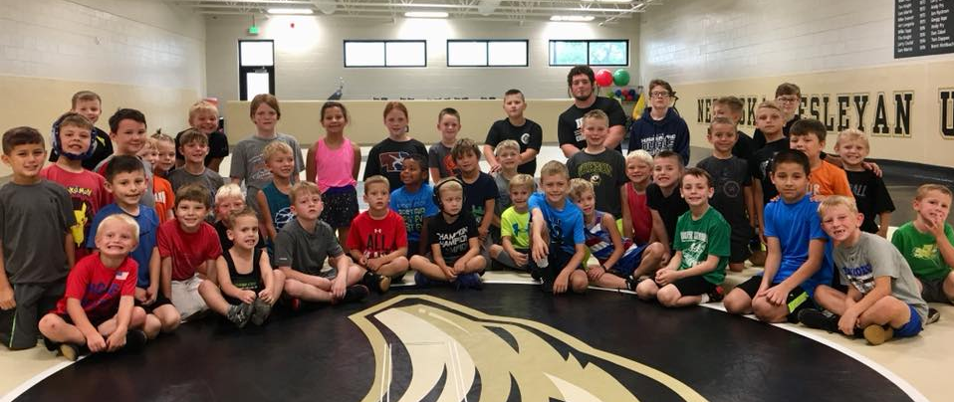
j
Results: We produce results for your wrestler on the mat. More than 25% of the wrestlers placed 1st or 2nd at state. That makes 1 out of every four practice partners from our past camps went on to be an NEUSA State Finalist in 2019, along with many other state placers who attended camp. Send your wrestler to a camp where you know they are going to have great partners and the coaching staff to give them an edge on their competition.
Who: Pre-K – 8th Grade, Broken into two groups:
Competitive wrestlers 3-8 yrs. experience & Beginner wrestlers 0-2 yrs. experience.
REGISTER BY 2/29/20 & SAVE 10%!
(Save $19.90!)
Coaches: Josh Gannon and his staff
Format:
- Focus on foundational drills, fixing common mistakes, repetition of core techniques, along with learning new techniques and focusing on the details for the experienced wrestlers
- Fun wrestling games that incorporate skill building
Daily Schedule:
- 8:00am – 9:00am Check-In at Wesleyan  - 9:00am – 11:00am Wrestling  - 11:00am – 11:30am Speed & Agility  - 11:30am – 12:30pm Lunch | - 12:30pm – 1:00pm Tumbling  - 1:00pm – 3:30pm Wrestling  - 3:30pm – 4:30pm Fun Activity  - 4:30pm – 5:00pm Pickup
Location: Nebraska Wesleyan’s wrestling room.
What to Bring: Wrestling shoes, t-shirt, athletic shorts, lunch and a bottle of water or sports drink.

