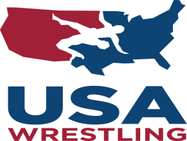
SMELTER CITY SMACKDOWN WRESTLING TOURNAMENT
March 7th , 2020

Memorial Gym, Corner of West 6th and Hickory
Anaconda, MT

Time: 9:00 a.m. Coaches and Referees Meeting
9:30 a.m. Wrestling Begins

Coaches: Only 1 coach allowed per 7 wrestlers (limited floor space)
$5.00 Hospitality Pass for Coaches

Registration: Pre-register on trackwrestling.com by Friday March 6th at 6 p.m.-$10.00/wrester. Weigh in is on the “honor system”
6U, 8U, 10U and 12U
Current USAW card is required, USAW cards will not be available for purchase

Admissions: $5.00 Age 5 and under-free

Contacts: Hosted by the Lil’ Copperhead Wrestling Club.

Nick Mikalatos 560-0550, Angie Sawyer 560-1482 or Dusty
Mikalatos 560-0038

Concessions: Available all day. No coolers allowed.

Awards: Medals: First-Third Place Ribbons Fourth-Sixth Place
Trophies for Small, Medium and Large Teams.

