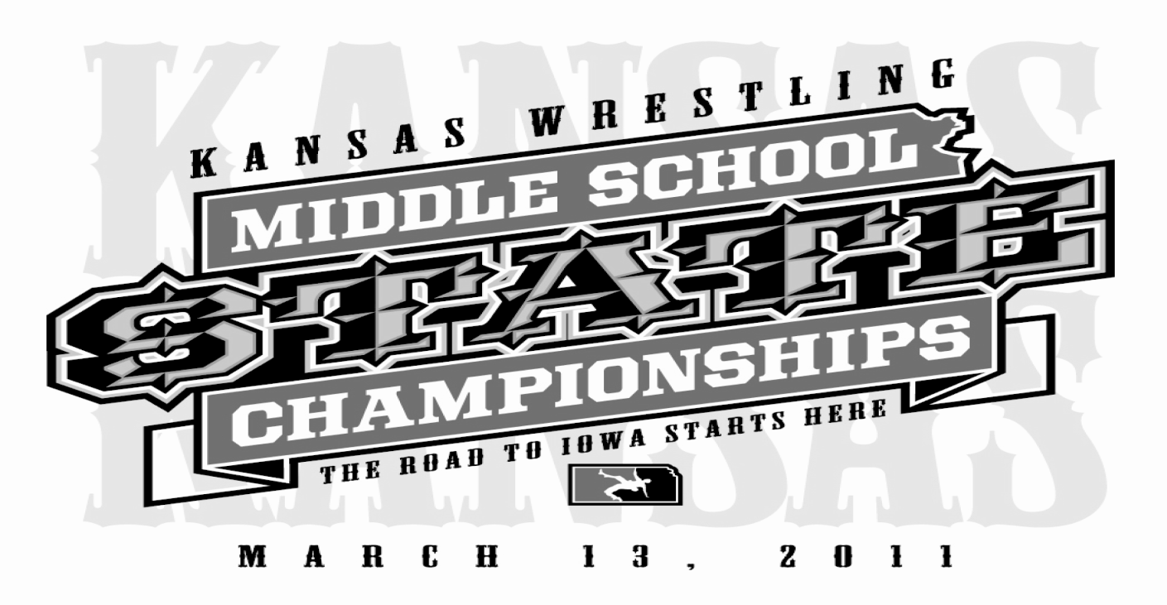
Kansas Middle School Championships
Qualifying tournament for the TEAM KANSAS Middle School Dual Teams going to Council Bluffs, IA on April 9-111 2020
Members on any wrestling organization currently enrolled in 6th through 8th grade. Maximum age is 15 in the 2020 year.
WILL BE TAKING 6 Team Plus Alternates

March 8th, 2020
Hutchinson High School
810 E 13th
Hutchinson, KS

Enter Fee: $20.00
Enter on TrackWrestling.com
Enter Deadline is March 5th at 11:59pm
Weigh In’s
NO WEIGHT ALLOWANCE WILL BE GIVEN
Saturday March 7th at District 1, 2, 3 & 4 @ 8:30am
Sunday March 8th, in Hutchinson from 7:00am to 7:30am

Wrestling starts at 9 AM

WGTS: 75, 80, 85, 90, 95 102, 110, 117, 125, 132, 140, 150, 160, 175, 195, 220, 275.
Customized, engraved medals, Tournament hoodie for the champion
Contacts:
James Cook-785-212-0605 jcook@maswu.org
James Bilby 316-650-9338 mustang0265@gmail.com
Will Cokeley wcokeley@silgancontainers.com

