Tony’s Event Center in Salina, KS
March 1, 2020
KANSAS 6 UNDER
STATE CHAMPIONSHSIPS
COME TAKE HOME THE BELT!!!!!
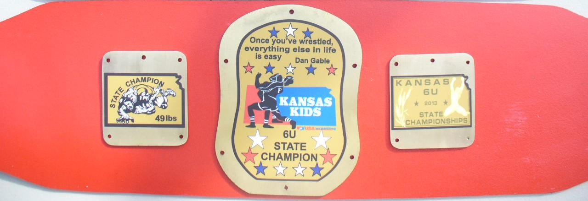
This event is sanctioned by Kansas USA Wrestling

Awards
Champions – Belt, 2nd – 6th Medals
Weight classes
37, 39, 41, 43, 45, 47, 49, 51, 53, 55, 58, 61, 64, 67, 70, 73, 80, 88, 95 & 110
Satellite Weigh in Sites: Wichita Area, TBD
Weigh ins: Saturday 6:30pm to 8:00pm –Tony’s Event Heritage Hall
Weigh ins: Sunday 6:30am to 7:30 am – Tony’s Event Center

Wrestling will start at 9:00 am
Entry Fee: $20.00
Enter on TrackWrestling.com
Entry Deadline is February 27th at 11:59pm
Admission $6.00

All Wrestlers must have a USA Wrestling Membership Card
Coaches must have Bronze Card
KSHSAA rules w/ kids modifications.

Elementary State Championships

March 1, 2020
Tony’s Event Center Salina, KS
Qualifying tournament for TEAM KANSAS Elementary School Dual Teams going to
Council Bluffs, IA on April 9-11, 2020
Age 1st-6th grade, must not be 14 or over at the time of the event.
We will be taking 6 teams to Iowa plus alternates

Enter Fee: $20.00
Enter on TrackWrestling.com
Enter Deadline is February 27th at 11:59pm
Satellite Weigh in Sites: TBD
Weigh ins: Saturday February 29th 6:30pm to 8:00pm Tony’s Event Heritage Hall
Sunday March 1, at the Tony’s Event Center from 6:30 to 7:30
Admission: $6.00
Wrestling starts at 9 AM

Weight Classes: 50, 55, 60, 65, 70, 75, 80, 85, 90, 95,100, 105, 112, 120, 130, 140 and 160
NO WEIGHT ALLOWANCE WILL BE GIVEN

Customized, engraved medals, Tournament hoodie for the champion
All matches will be 1 ½ periods

Contacts:
James Cook-785-212-0605 jcook@maswu.org

Dal Eck- 316-641-4913 dal@matteck.com

All Wrestlers must have a USA Wrestling Membership Card
Coaches must have Bronze Card
KSHSAA rules w/ kids modifications.

