New London Bulldogs Lady Wrestling Bash

Sunday – February 16, 2020
held at
New London High School
1700 Klatt Rd. New London, WI 54691

ONLINE PRE-REGISTRATION ONLY via Trackwrestling.com
No USA card required
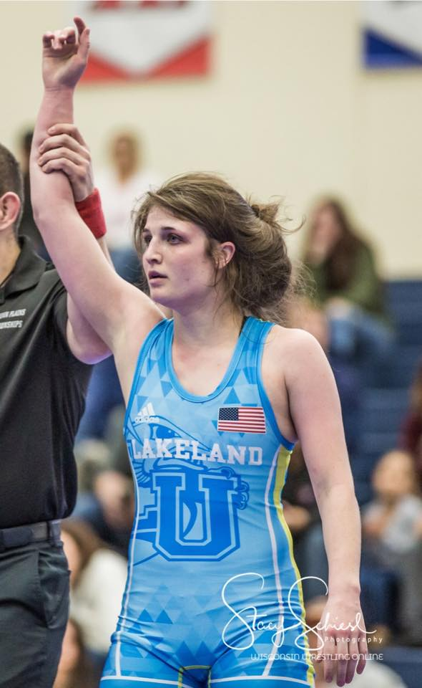
$20.00 Entry Fee

NO Weigh-Ins – Preregistration weight being used
Wrestlers should check in between 8:00am-9:00am
Tournament Starts at 10:00am

FREE Wrestling Clinic from 9:00am – 9:45am with
Lakeland University’s Maddie Ruckdashel

GIRLS Divisions: PreK-K, 1-3, 4-6, 7-8

4 Person Round Robin
Folk Style – (3) one minute periods
WIAA Officials on ALL Mats

1st – 4th place Medals
Champion T-Shirts for 1st place

Concessions Available All Day

Tournament Held Regardless of Weather-No Refunds-No Exceptions
Contact Nathan Krueger with questions:
nkrueger42@gmail.com or 920-359-0738

