Clash of the Titans Freestyle Open & Greco Roman Open

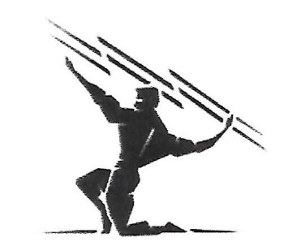
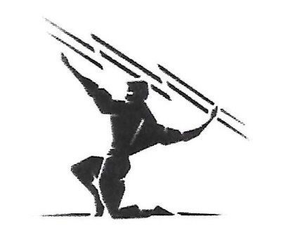
Sunday, April 26, 2020

Gibson Southern High School
3499 W 800 S
Fort Branch, IN 47648

Contact Name: Kara Polen
Phone: 812-686-0263
Email: karatodd@frontier.com

SANCTION - ELIGIBILITY
Tournament is sanctioned through the Indiana State Wrestling Association by
USA Wrestling and is open to all 2019-2020 USA Wrestling members.
This is a qualifier for Freestyle State Finals.

ENTRY FEE:
$20 per event or $30 for both
Day of event is $20 per event

AGE DIVISIONS:
Pee-Wee 6U, Bantam 8U, Int. 10U,
Novice 12U, Schoolboy/girl 14U.Cadet 16U,
Junior, University, Senior, & Veteran

REGISTRATION & WEIGH-INS:
Pre-register online @ trackwrestling.com
Deadline to pre-register is Saturday, 4-25-20 @5:30pm (cst)

Weigh-ins will be from 7-8am, day of event
Walk-ins will be accepted during weigh-ins

Tournament Start Time:
Freestyle will start right at 9
Greco will begin 30 minutes from the conclusion of Freestyle

AWARDS:
Medals: 1st-3rd place
Team Trophy for 1st Place (Both Freestyle & Greco)

Spectator Fee
$5.00 per person – Kids 10 & under FREE
$15 for family

Additional Information:
Concessions available all day

USAW cards must be purchased at www.usawmembership.com

