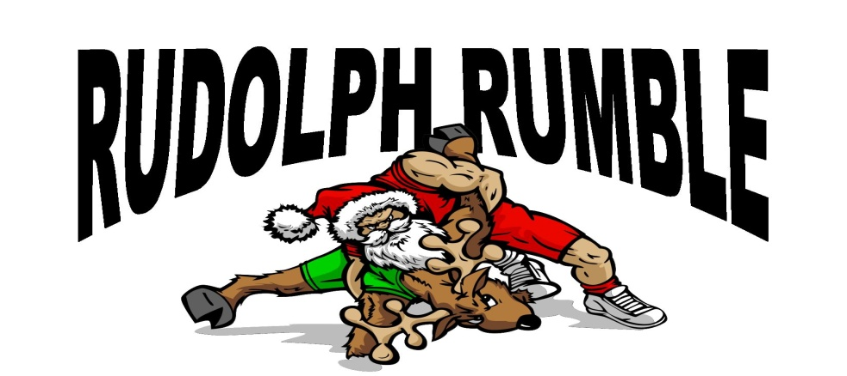

2019 Sparkman High School
Middle School and JV Tournament
2616 Jeff Rd NW, Harvest, AL 35749
Date: Saturday, December 21, 2019

Entry: $125 per team (up to 20 wrestlers). Additional wrestlers $5 each.
$10 per wrestler for less than 10 wrestlers. Make check payable to Sparkman High School Wrestling.

Weigh in: Weigh-ins will begin at 7:00 am.

Awards: Middle School Individual – 1st, 2nd, 3rd
J.V. Individual – 1st, 2nd, 3rd
Team – 1st and 2nd
Middle School
Weights:
75, 85, 95, 103, 112, 119, 125, 130, 135, 145, 155, 165, 175, 195,​ ​220, 285
No seeding
J.V.
Weights:
106, 113, 120, 126,132, 138,145, 152, 160, 170, 182, 195, 220, 285
No seeding

Format: Will vary based on number of wrestlers per division

Hospitality Room available for coaches and officials!

Thank you and have a great season!

Sparkman Wrestling
Ronnie Watson
Cell: 256-658-2743
Email: rwatson@mcssk12.org

