2020 Beast of Eastern Kansas Open
(Hosted by Mill Valley Kids Wrestling Club)

Date: February 8th, 2020. Doors open at 7:00 a.m.
Location: Mill Valley High School (5900 Monticello Road, Shawnee, Kansas 66226)
Format/Time: Split Session Open Tournament (6u, 8u, 10u, 12u, and 14u)
Coaches Meeting- 8:00
Wrestling:
A.M Session – 8:30 a.m. 6U, 10U, 14U
P.M. Session – At conclusion of A.M. session (approx 12:30 p.m.) 8U, 12U

Registration and Fee: Register online at www.trackwrestling.com $25 per wrestler NON-REFUNDABLE (pay online)
Admission: $3.00 (under 12 free); Coaches are free with USAW coaches card. Concessions: will be available all day.
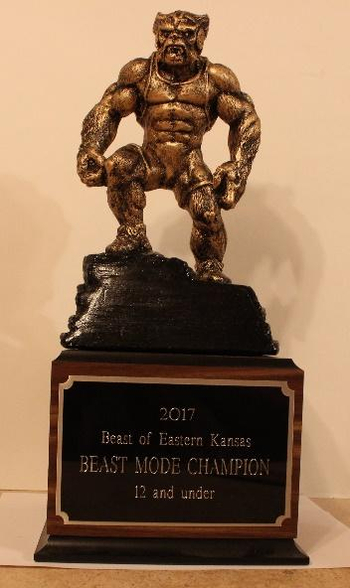
Entry Deadline: February 5th, 2020 by 11:59 p.m. We will limit registration to the first 700 entrants. No double dipping.
Contact Information: Jeremiah Nilges (Director) Email at: jjndvm@gmail.com
Weigh In Information: Remote weigh-ins only. Weigh-in instructions will be emailed to club directors February 7th.
Awards: Champion in each open bracket receives CUSTOM 10” BEAST TROPHY
3” Custom Beast Medals for 2nd & 3rd place, and standard medals for 4th place in each bracket
Outstanding Wrestler: CUSTOM “BEAST MODE” TROPHY in each age group

Rules: KSHSAA rules as modified by USAWKS, Kansas Kids rules apply
Division | Weight Classes
6 and Under | 37, 40, 43, 46, 49, 52, 55, 58, 61, 64, 67, 70, 73, 76, 80, 88, 95, 110
8 and Under | 40, 43, 46, 49, 52, 55, 58, 61, 64, 67, 70, 73, 76, 80, 88, 95, 110, 125, 140
10 and Under | 52, 55, 58, 61, 64, 67, 70, 73, 76, 79, 82, 85, 90, 95, 100, 110, 120, 130, 150, 170, 190
12 and Under | 64, 68, 72, 76, 80, 84, 88, 92, 96, 100, 105, 110, 115, 120, 130, 140, 150, 165, 190, 215, 240, 265
14 and Under | 75, 80, 85, 90, 95, 100, 105, 110, 115, 120, 125, 130, 135, 140, 145, 150, 155, 160, 165, 175, 205, 235, 265
Double elimination and round robin brackets will be used depending on the number of participants. We reserve the right to combine weight brackets.

Members and parents of the Mill Valley Kids Wrestling Club, Mill Valley High School, their employees, administrators, and/or Desoto School District USD #232 are not responsible for any injuries, accidents, theft or vandalism during the tournament on the premises or parking lots.

Area Hotels:
Courtyard Kansas City-Shawnee
17250 Midland Drive
Shawnee, Kansas 66217
913-631-8800

Holiday Inn Express & Suites Shawnee – Kansas City West
17346 Midland Drive
Shawnee, Kansas 66217
913-400-2509

Hyatt Place Kansas City/Lenexa City Center
8741 Ryckert Street
Lenexa, Kansas 66219
913-742-7777

Great Wolf Lodge Kansas City
10401 Cabela Drive
Kansas City, Kansas 66111
800-608-9653

