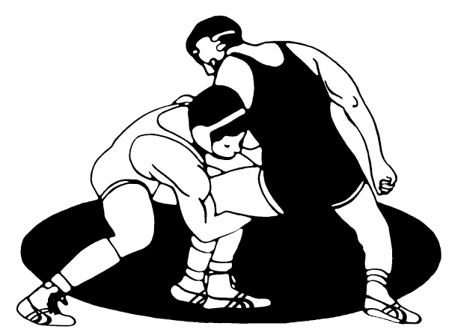
Campbellsport
Youth Wrestling

We invite your wrestling team to come kick off the season at our folk style tournament on
-Folk style Round Robin
3-1 min periods
5 man brackets when possible
Saturday December 21, 2019
*Track Wrestling with 2 sessions*Limit 350 wrestlers*$20 per wrestler
1st Session—2009-2010/2011-2012/2013-2015
- Check in: 6:30-7:30
- 8:00am Wrestling Begins
No weigh ins! (must register your wrestlers weight online)
Will check weight if it is questioned.

2nd Session—2005-2006/2007-2008
- Check in: 9:30-10:30
- 11:30am Wrestling Begins

NO WALK INS & NO SPECTATOR FEE

Register at Track Wrestling-http://www.trackwrestling.com
Registration end----- Dec 20th ending @2pm
USA Card required and will be available at the door for $40 (must have birth certificate to obtain)
Medals and t-shirt for 1st place
2nd-3rd-4th-5th place medals

TEAM TROPHY: 1ST THRU 2nd PLACE
$10 Entry fee for team

In consideration of acceptance of this entry: I, intending to be legally bound hereby waive and release Campbellsport Youth Wrestling Club, Campbellsport School District, their names and agents from any claims or rights to damages for injuries or losses suffered by me directly or indirectly while traveling to or from, competing in or attending this tournament, I also understand that I am responsible for my own insurance.

++++++++++++++++++++++++++++++++++++++++++++++++++++++++++++++++++++++++++++++
Campbellsport High School - 114 W Sheboygan St. Campbellsport, WI 53010
campbellsportyouthwrestling@yahoo.com
Jodie Ksioszk-920-960-0095******** Sarah Bentz 920-889-2387

