RUMBLE AT THE ROCK
Saturday, November 30, 2019
Deschutes County Fair & Expo Center
3800 SW Airport Way, Redmond, OR 97756
Weigh-ins: Friday 6pm – 7pm @ Redmond High School (675 SW Rimrock Way, Redmond)
Saturday 7am – 8am @ Expo
Tournament starts at 9:30am
First Place: CHAMPION SINGLET
(3 man bracket to qualify)
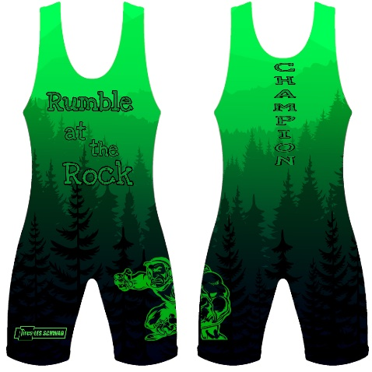
Medals: 2nd – 4th
6U 8U 10U 14U 16U USA Juniors
8U Girls 10U Girls 12U Girls 14U Girls 16U Girls USA Junior Girls
Line Bracketing – 10 Full Size Mats
$25 Pre-registered / $35 @ Door
$15 Floor Pass / $3 Spectator Fee
www.trackwrestling.com
Full concessions provided by the Expo Center

Hosted by Rock of Redmond Wrestling
www.therockwrestling.org

