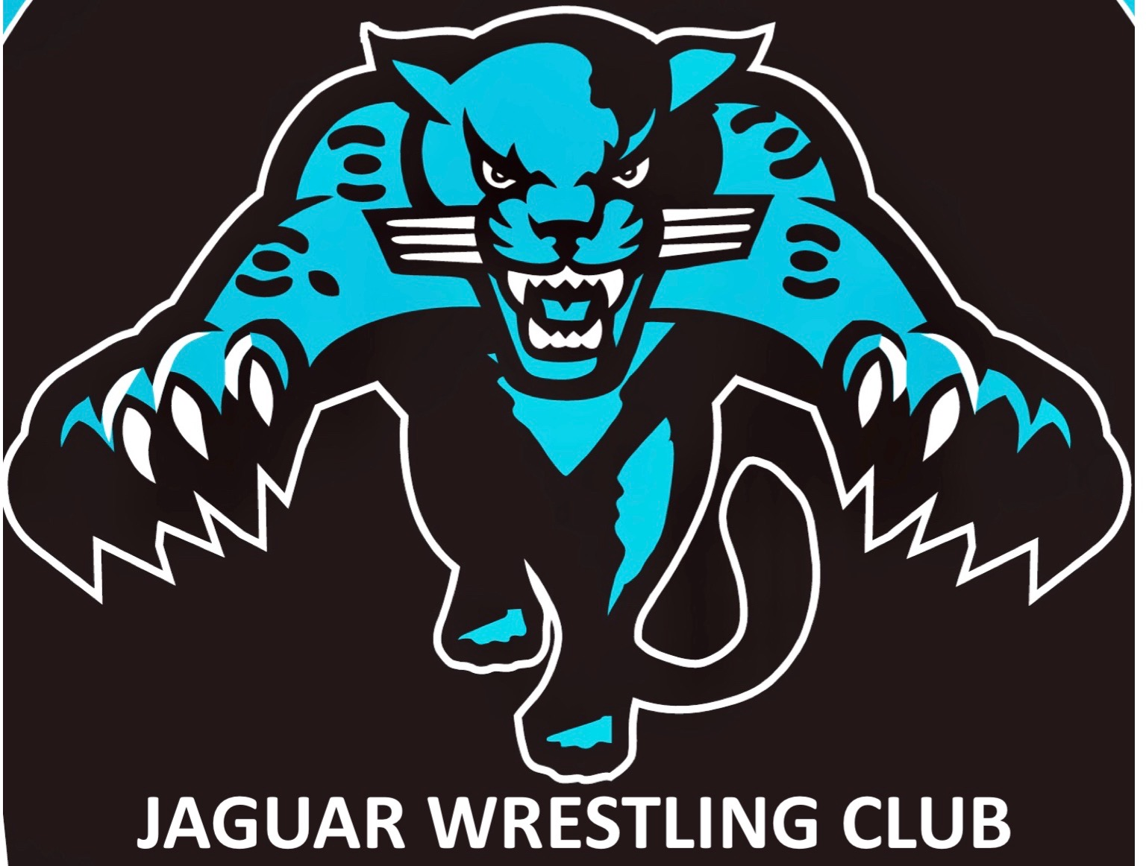 THE TRI-COUNTY TUNE UP
26 OCTOBER 2019
OVERHILLS HIGH SCHOOL
2495 RAY RD, SPRING LAKE NC 28390

Hosted by: Jaguar Wrestling Club

Who: 9th Grade to 12th Grade - Male and Female Wrestlers

Registration Fee: $25.00 if preregistered by 19 October 2019 10:00pm / $35.00 registrations at the door or after Per-Reg deadline

Registration Limit: 500

Registration at: http://www.trackwrestling.com/registration/BasicPreReg1.jsp?tournamentGroupId=156576132

Spectator Fee: $10.00 per adult / $5.00 if under 10 yrs. old / 3 years and younger free

Weigh Ins: 7:00 am to 8:30 am (3 lb. allowance)

Wrestling Uniform: Singlets or Compression Shirt and Shorts without pockets, Wrestling shoes, Headgear optional. Mouth protection required for all wrestlers with Braces or Orthodontic Devices on teeth.

Wrestling Starts: As close to 9:30 am as possible.
Tournament Match Times: Championship Brackets 2-2-2 min periods / Consolation Brackets 2-1-1 min periods
Awards: Medals for 1st,2nd, and 3rd Place.
All wrestlers must bring completed waiver form to weigh ins to be able to participate.
There will be a three-pound allowance for all weight classes. There will be a skin check immediately following your weigh in. If you do not make weight for the registered weight class, you will be moved to the weight class above registered weight.
There will be no REFUNDS for any reason.
Weight Classes: 106 , 113 , 120 , 126 , 132 , 138 , 145 , 152 , 160 , 170 , 182 , 195 , 220 , and 285.
Tournament Director Contact Info: John Moshman, Jaguar Wrestling Club, overhillswrestling@gmail.com

TRI-COUNTY TUNE UP: Waiver and Release of Liability
DISCLAIMER: JAGUAR WRESTLING CLUB, TRI-COUNTY TUNE UP, OVERHILLS HIGH SCHOOL, HARNETT COUNTY BOARD OF EDUCATION, ITS AGENTS, OR EMPLOYEES ARE NOT RESPONSIBLE FOR ANY INJURY (OR LOSS OF PROPERTY) TO ANY PERSON SUFFERED WHILE PLAYING, PRACTICING, OR IN ANY OTHER WAY INVOLVED IN THE TRI-COUNTY TUNE UP FOR ANY REASON WHATSOEVER, INCLUDING ORDINARY NEGLIGENCE ON THE PART OF JAGUAR WRESTLING CLUB, TRI-COUNTY TUNE UP, OVERHILLS HIGH SCHOOL, HARNETT COUNTY BOARD OF EDUCATION, ITS AGENTS, OR EMPLOYEES
In consideration of my child's participation, I hereby release and covenant not-to-sue Jaguar Wrestling Club, The Tri-County Tune Up, Overhills High School, Harnett County Board of Education, its agents, employees, instructors, or coaches from any and all present and future claims resulting from ordinary negligence on the part of Jaguar Wrestling Club,The Tri-County Tune Up, Overhills High School, Harnett County Board of Education, or others listed for property damage, personal injury, or wrongful death arising as a result from ordinary negligence, both present and future, that may be made by me, my child, my family, estate, heirs, or assigns.
Further, I am aware that Wrestling is a vigorous sport involving severe cardiovascular stress and violent physical contact. I understand that Wrestling involves certain risks, including but not limited to, death, serious neck and spinal injuries resulting in complete or partial paralysis, brain damage, and serious injury to all bones, joints, muscles, and internal organs; and that equipment provided for my child's protection may be inadequate to prevent serious injury. I further understand that Wrestling involves a particularly high risk of knee, head, and neck injury. In addition, I understand that participation in Wrestling involves activities incidental thereto, including, but not limited to, travel to and from the site for the activity, participation at sites that may be remote from available medical assistance, and the possible reckless conduct of other participants. I am voluntarily allowing my child to participate in this activity with knowledge of the danger involved and hereby agree to accept any and all inherent risks of property damage, my child's personal injury, or my child's death.
I further agree to indemnify and hold harmless Jaguar Wrestling Club, The Tri-County Tune Up, Overhills High School, Harnett County Board of Education, and others listed for any and all claims arising as a result of my child engaging in or receiving instruction in the Tri-County Tune Up activities or any activities incidental thereto, wherever, whenever, or however the same may occur.
I understand that this waiver is intended to be as broad and inclusive as permitted by the laws of North Carolina and agree that if any portion is held invalid, the remainder of the waiver will continue in full legal force and effect. I further agree that the venue for any legal proceedings shall be in North Carolina.
I affirm that I am of legal age and am freely signing this agreement for my child to participate in The Tri-County Tune Up. I have read this form and fully understand that by signing this for I am giving up legal rights and/or remedies which may be available to me for the ordinary negligence of Jaguar Wrestling Club, The Tri-County Tune Up, Overhills High School, Harnett County Board of Education, or any parties listed above.
______________________________ Signature of Wrestler
______________________________ Print Name of Wrestler
____________________ Date
___________________________________ Signature of Parent or Guardian

