Date: Saturday, December 14, 2019
Location: Southern Boone High School
14520 S. Crump Lane
Ashland, Mo 65010

Weigh Ins: 7:00am-8:30am in the Library
Wrestlers must wear their singlets to weigh-ins
Entry Fee: $20.00
Registration deadline: December 9, 2019
Admission: $3.00 for adults, $2.00 for students, children under 5 are free
Concessions: Available throughout the tournament. Coolers allowed in the commons area only. Absolutely no food or drinks in the gymnasium.
Hospitality Room: Available for coaches, officials and volunteers
Format: SPLIT SESSION FORMAT
6U/8U/10U- Wrestling begins at 9:00 am sharp. Round robin using USA Wrestling age groups. Bullpen will be used.

12U/14U- Wrestling will begin at 12:00 pm, or after the conclusion of 6U/8U/10U.
Round robin using USA Wrestling age groups. Bullpen will be used.

REGISTRATION: Registration is through www.trackwrestling.com
Search Southern Boone Eagle Classic Wrestling Tournament
Press control and click HERE for quick access
Contact info: SoBowrestlingclub@gmail.com
Derek Mordica: 573-864-0656
Steve Wilmoth: 573-999-3399
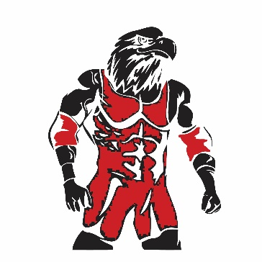
Team points
Pick your top 10 wrestlers for team points and give names to the head table
1st place= 3pts
2nd place= 2pts
3rd place= 1pt
Trophies will be given to the top three teams at the tournament
