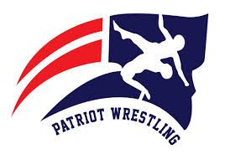2019 PATRIOT JV/ MIDDLE SCHOOL TOURNAMENT

DATE: Saturday, February 2nd, 2019

FORMAT:
J.V. - Double Elimination from a 16 man bracket.
Wrestlers will be placed in bracket by random draw.

Middle School – We will be using scramble pairing to ensure kids get as many matches as possible.

FEE: $10.00 per wrestler payable to North Vermilion High School

LINE-UPS: Please enter line-ups on trackwrestling by 7:00 p.m. Wednesday, January 30th.

*Middle school coaches need to enter criteria listed to ensure that wresters are matched properly. (grade level, actual weight, experience level, USA wrestling card #.)

WEIGH-IN: J.V. – Beginning - 7:30 a.m.
Middle School – 8:00 a.m.
Wrestling will begin at approximately 9:30 a.m.

PLACEMENT: Four Places (JV only)

AWARDS: For JV tournament only:
1st & 2nd Place Team Trophies
1st – 3rd Place Individual Medals
Outstanding Wrestler Trophy

SCHOOL ADDRESS: 11609 LA Highway 699
Maurice, LA 70555

Contact Info: CELL: 337-984-9074
SCHOOL: 337-898-1492
E-MAIL: michael.stelly@vpsb.net

Mike Stelly
Head Wrestling Coach

