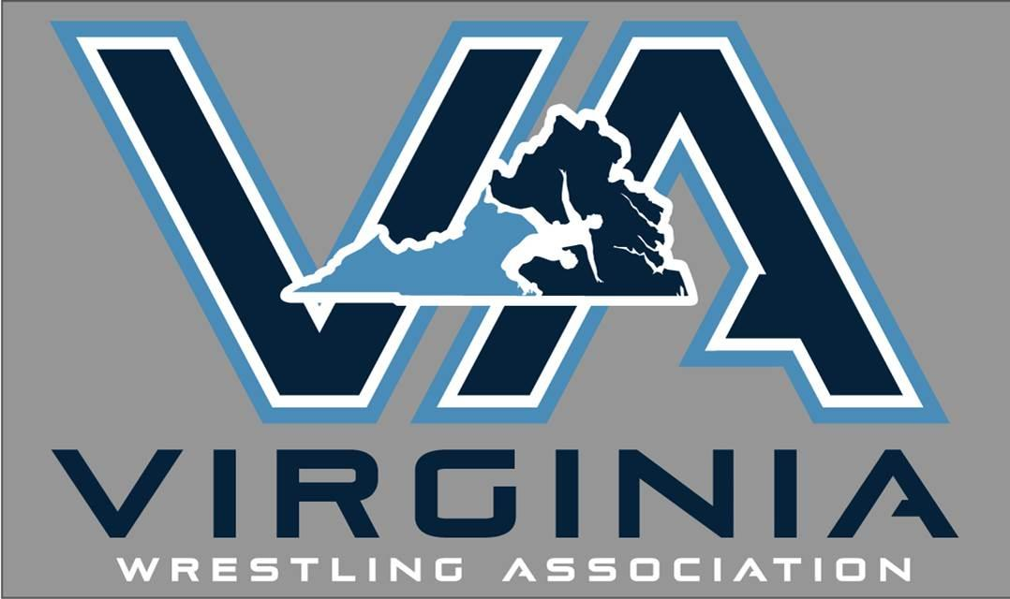

Outside food is prohibited by the Ashe Center. It is not our rule. Be prepared to have bags checked. No lawn chairs allowed.

DATE: Sunday January 21,2018 - Dual Team State Championships
LOCATION: Arthur Ashe Center 3001 N. Boulevard, Richmond
DIVISIONS: Dual Team – Elementary School k-5th, Middle school 6th-8th
We will accept the first 10 ES and MS teams

TOURNAMENT DIRECTOR: Jack Harcourt; jack.harcourt@virginiawrestling.com
STATE KIDS DIRECTOR: Paul Boswell, 757-831-0642; PAUL.J.BOSWELL@GMAIL.COM
SECRETARY OF OPERATIONS: Bill Grubbs, 757-207-1518; 2GRUBSWRESTLE@GMAIL.COM

DUAL TEAM ENTRY FEE: $375.00, If your club enters a ES and an MS team you will receive a $50 discount. ($750-$50 = $700 total) Email Jack Harcourt to confirm your clubs spot in the elementary and/or middle school dual tournaments. Payment will be due by Friday January 12th. Checks made out to Virginia Wrestling Association send check to 3449 Robinson Rd, VA Beach, VA, 23456. Club teams only. NO All-star teams! If you are unable to fill your roster you may draft up to 4 wrestlers from another club in VA. Make sure your wrestlers are affiliated with your club. This is done at the membership page for each wrestler. Only the wrestler can do an affiliation with another club. A club leader/coach cannot do this process.

ADMISSION: Adults - $10.00, Students $5 Non school age kids free
(Under 12 and coaches with current membership free)
COACHES: Must show current membership to obtain matside coaching floor pass. Go to this site to obtain a coach's card 2 weeks in advance of this event if you have not. HTTP://WWW.USAWMEMBERSHIP.COM. If you need assistance contact Jack Harcourt 757-435-3876. If you do not have an active coaching membership there will be a $25 fee to be matside in addition to admission to the event.

COMPETITORS: Must provide proof of current membership to participate. Be prepared to provide proof of age if challenged.
Head gear and mouth guard for braces required

WRESTLING GEAR & APPAREL WILL BE SOLD ONSITE BY BLUE CHIP WRESTLING

AWARDS: For top 3 teams in each division. Medals to wrestlers that are undefeated, one or 2 losses
DUAL TEAM WEIGHTS:
Elementary k-5th : 40, 45, 50, 55, 60, 65, 70, 75, 80, 85, 90, 95, 100, 105, 112, 132 MAX
Middle school 6th – 8th: 65, 70, 75, 80, 85, 90, 95, 100, 105, 112, 119, 126, 135, 145, 155, 175, 250 MAX

WEIGH-INS:

Wrestlers must have a singlet on to weigh in. On site trainers and VAWA officials for skin checks

Schedule
Arthur Ashe Center
Friday January 19th – 6pm with the Wrestlefest Weigh ins and skin checks
Sunday January 21 - 8-8:30 Weigh ins and Skin check

Regional Weigh-in Sites: (2017 SITES LISTED BELOW-working on 2018 event)
-NORTHERN VIRGINIA: HAYFIELD HS
-WINCHESTER AREA: SKYLINE HS
-CENTRAL REGION (RICHMOND): ARTHUR ASHE CENTER
-FREDERICKSBURG AREA: COLONIAL FORGE HS
-EASTERN REGION (TIDEWATER): POQUOSON MIDDLE SCHOOL
-EASTERN REGION (VIRGINIA BEACH): VA Sharks Wrestling Club
-WESTERN REGION (ROANOKE AREA): HAWKEYE HALL CHRISTIANSBURG
-LYNCHBURG AREA: LIBERTY U WRESTLING ROOM
-UVA WRESTLING ROOM IN ONESTY HALL AT UVA CAMPUS
-SOUTHWEST REGION: GRUNDY WRESTLING ROOM

9:30 FIRST ROUND FOR DUAL TEAM CHAMPIONSHIPS

