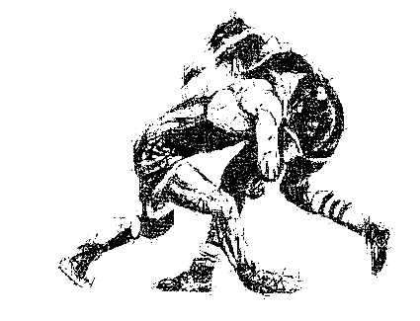
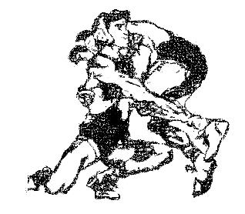
4th Annual
BRUIN INVITATIONAL

LOCATION: Bonnabel High School
2801 Bruin Drive
Kenner, LA 70065

DATE: Saturday, January 27, 2018 @ 9:30am

WEIGH IN: Saturday, January 27, 2018 @ 8:00am

ENTRY FEE: $10 per wrestler (Multiple entries will be allowed if space permits)
**Makes checks payable to Bonnabel High School
**Fees are due at time of weigh in

ROSTERS: All entries must be submitted using trackwrestling.com

FORMAT: Double elimination tournament- Varsity
Using NFHS rules

AWARDS: 1st, 2nd, 3rd Place, 1st Place Team, and Most Valuable Wrestler

CONTACT: Coach Michael Lachney- (504) 621-6313
Email: mlachneyjr@yahoo.com or michael.lachney@jppss.k12.la.us

Entry information must be received via trackwrestling.com by Friday, January 26th at 10:00am. In the event of a change or difficulties using trackwrestling.com you may email me your entries at the email address listed above. All entries are final after the deadline.

**PLEASE CALL/EMAIL WITH YOUR INTENT AT YOUR EARLIEST CONVENIENCE**

