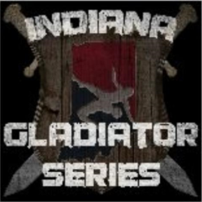
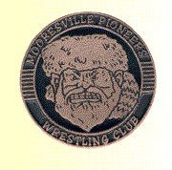
MOORESVLLE FREESTYLE OPEN

Saturday, April 21, 2018

LOCATION
Mooresville Consolidated High School
550 North Indiana Street, Mooresville IN 46158
From State Road 67, Go west on S.R. 144 to 1st light & turn right onto Indiana Street, Take Indiana through 1st light to the 1st 4-Way stop. School is on the left.

CONTACT
Joe or Beth Lybarger
Phone: 317-440-1909
E-mail: bethlybarger@hotmail.com

SANCTION - ELIGIBILITY
Tournament is sanctioned through the Indiana State Wrestling Association by USA Wrestling
and is open to all 2017-2018 USA Wrestling members.

AGE DIVISIONS ENTRY FEE
PEE-WEE – JUNIOR $15.00

REGISTRATION  All registration and payment must be completed  on-line @ trackwrestling.com by 11:59 noon Friday 04-20-2018(EST)  No late entries No exceptions! | WEIGH-INS  On site Weigh-in  Friday April 20,2018 6:00pm-8:00pm  Saturday April 21,2018 7:00am-8:00am  All wrestlers MUST have an official weigh in  No Exceptions
TOURNAMENT START TIME
Wrestling begins at 9:30 am on Saturday morning

AWARDS
Medals to 1st - 2nd - 3rd
Ribbons to 4th - 5th - 6th

SPECTATOR FEE
$5.00 per person—$10.00 per family

ADDITIONAL INFORMATION
Concessions available on site
Singlets, headgear and mouth guards are mandatory
Jim’s Wrestling Supply will be offering equipment for sale

USAW cards required purchase at www.usawmembership.com

PART OF THE INDIANA GLADIATOR TOURNAMENT SERIES
FOR MORE INFORMATION "LIKE" OUR FACEBOOK PAGE

