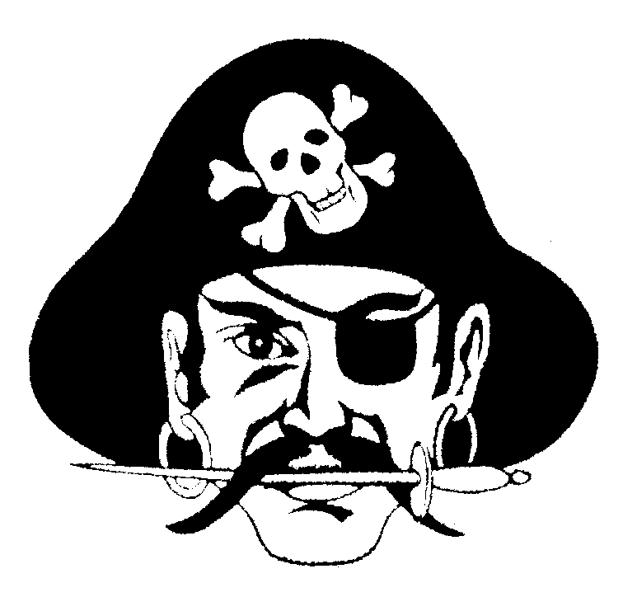
2018 Port Washington Wrestling Club Friday Night Freestyle Event

Friday - April 20th, 2018
Divisions
5th – 6th Grade
7th – 8th Grade
9th – 10th Grade
11th – 12th Grade
University
Brackets
4-man round robin where possible
Awards
Medals 1st & 2nd Place for 5th – 8th Grade Divisions
Entry Fee
$15 entry fee - Pre-register: TrackWrestling
NO Walk-ins
NO Weigh-ins
We will bracket Friday Afternoon, so we have a prompt start
Check-ins 5:00 pm – 5:30 pm
Rules Clinic 5:45
Wrestling starts approximately 6:00 pm
Location
Port Washington High School
427 W Jackson St
Port Washington, WI 53074
Admission
Adult admission - $3
Child admission - free
Concessions will be available
Tournament Directors:
Scott Peiffer 414.916.0000 scott@spectrumit.net
Angelo LaRosa 262.268.5640 Angelo.LaRosa@pwssd.k12.wi.us

This is a USA Sanctioned Wrestling Tournament. USA Cards will be required during pre-registration for 5-12th Grade.
Every attempt will be made to wrestle 3 matches per round robin unless a weight problem occurs. Enter your wrestler’s actual weight accurately in Track Wrestling during pre-registration.

