AAU Eastern Grand Nationals
July 19 – 21, 2018

Triple Crown  Champion Jacket  Place 1st in all three styles  and this Jacket is yours  (Greco – Freestyle - Folkstyle)  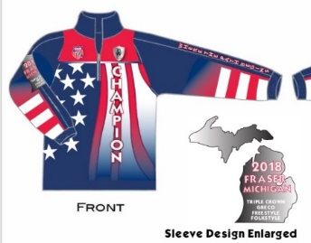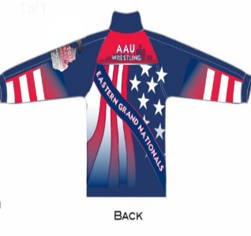  MEDALS:  1st – 8th place – Each Style  AAU T-Shirt for all participants  Visit our Webpage miaaugreatlakeswre.wix.com/wrestling  For More Event Information including  Age Divisions – Weight Classes – Hotels | LOCATION:  Fraser Hockeyland  34400 Utica Road  Fraser, MI 48026  SCHEDULE:  WEIGH-INS  Thursday July 19, 2018 - 3:00 pm – 6:00 pm  COMPETITION  Friday July 20, 2018 - Greco Roman & Freestyle  Saturday July 21, 2018 - Folkstyle  Start time Friday and Saturday – 9:00 am  ENTRY FEE:  Three Styles – One Price  $50.00 Early Pre-Registration by July 8, 2018  (Name will be included on Event Shirt)  $60.00 Late Registration July 9 – July 16, 2018  (Name will not be included on Event Shirt)  Register on Track Wrestling @  AAU Eastern Grand Nationals  All Athletes and Coaches must have an AAU Membership  Please visit the AAU website www.aausports.org  or visit our Webpage to obtain your membership  Contact Information:  Karen Wilson- miaau.greatlakeswrestling@yahoo.com  Cindi Trombly – cinditrombly@aol.com

2018 AAU Non-Athlete Membership (coaches) and Adult Membership is No Longer Instant
Join us in protecting America’s youth by taking the next logical step with background screening for all.
This is a benefit of your Non-Athlete and Adult Membership and is included in your Membership Fee. “Please Apply Early”
- Non-Athlete and Adult Membership cannot be sold on-site.
- This event is licensed by the AAU Amateur Athletic Union of U.S. Inc.
- AAU membership may not be included as part of the entry fee

