Adams Central Trophy Challenge

Grades Pre-K through 8th Grade
Friday, March 2, 2018
Adams Central High School
Entry Fee and Registration: $15.00 is due with the online registration on or before March 1^{st.}
$20.00 for entries received after 11 p.m. March 1st or for walk-ins the day of tournament.

Medals will be awarded for top four wrestlers in each weight class.
Winners of each bracket may challenge for a Takedown Trophy. If a wrestler wins his bracket he will be paired with a winner(s) of another bracket for a takedown challenge.
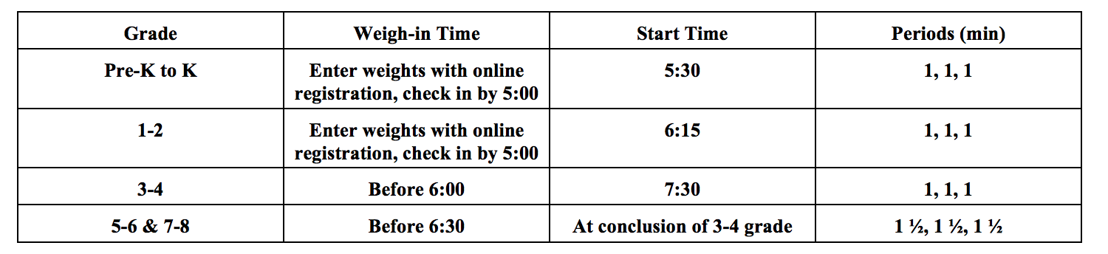

Weigh-ins: Weight will be done at home with the honor system. Please ensure your coach has given your child’s weight to you. Questionable weights of wrestlers will be checked. All brackets 4-man round robin. No set weights, will match up as close as possible by grade/weight for bracketing purposes.
Admission: Adults $4.00 Students: $2.00
Awards: Medals will be given to top four places.

Officials: AC High School wrestlers will officiate with the supervision of a certified official.
Concessions: Concessions will be served.

In case of bad weather: Call 402-705-0697 (Chad) or 402-984-6325 (Dan). REGISTER ONLINE: go to trackwreslting.com, browse for Adams Central Trophy Challenge or this link: http://www.trackwrestling.com/registration/

By completing the online registration, you are accepting this waiver of liability: I certify the above information is correct and the above registered wrestler has my permission to participate in the Adams Central Youth Wrestling Club Tourney. I release Adams Central Public Schools, Adams Central Wrestling Club, and any and all other agents from any responsibility, and/or liability in case of an accident or injury. I hereby authorize medical treatment to be administered by licensed personnel in the case of an accident or injury.

