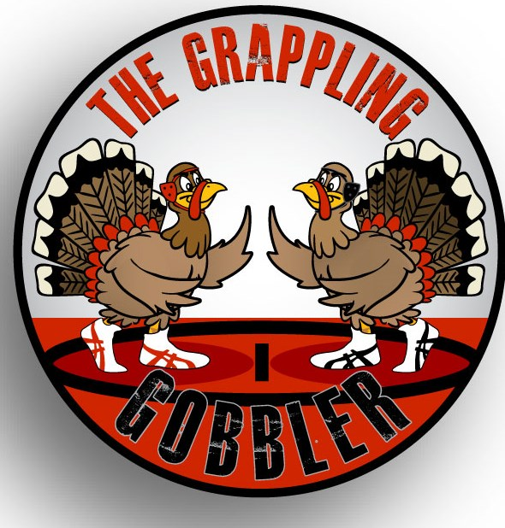
THE GRAPPLING GOBBLER

Saturday, November 25, 2017
Roosevelt High School
(616. N 2nd Street, Johnstown, CO)

Registration: $20.00
Register Online ONLY at www.trackwrestling.com
Deadline: Friday, November 24, at 2:00 pm

Weigh Ins:
This tournament will not have a weigh-in. It is being done on the honor system. However, there will be spot checks done at random mats. We will also allow a weight check challenge system. On a spot check you must be with-in 2 pounds of the weight class.

Wrestling Begins at 9:00am
(Doors open at 7:30am / Concessions open at 7:30am)

Admission:
Adults-$5.00/ Kids and Seniors (65 and older)-$3.00/ Under 5 is FREE

Ages determined as of 09/01/2017
4 & Under, 6 & Under, 8 & Under, 10 & Under, 12 & Under, and 15 & Under
NO HIGH SCHOOL WRESTLERS
General Information:
- Weight Classes are Madison block bracketing with 4, 5 or 6 man round robins.
- Custom medals awarded for 1st thru 3rd place.
- Double-bracketing permitted across age groups.
- NO REFUNDS
Wrestling Periods:
- Age Groups 4, 6 & 8: 1-1-1
- Age Groups 10, 12 & 15: 1.5-1.5-1.5
Sponsored by Rough Rider Youth Wrestling & Roosevelt High School Wrestling
For more information please email: roughrideryouthwrestling@gmail.com
or contact
Josh Robinson (970) 380-5559.

