2018 Beast of Eastern Kansas
(Hosted by Mill Valley Kids Wrestling Club)

Date: February 17, 2018. Doors open at 7:00 a.m.
Location: Mill Valley High School (5900 Monticello Road, Shawnee, Kansas 66226)
Format/Time: Coaches Meeting- 8:00
Wrestling A.M Session – 8:30 a.m. (6U, 8U, 12U)
Wrestling P.M. Session – 12:30 p.m. (10U, 14U)
Double elimination and round robin brackets will be used depending on the number of participants.

Registration and Fee: Register online at www.trackwrestling.com
$20 per wrestler NON-REFUNDABLE (pay online)

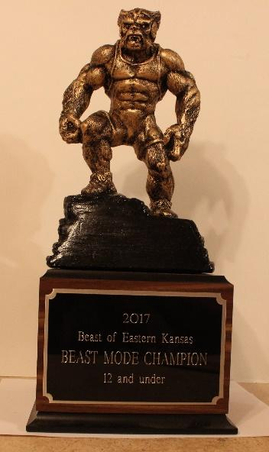
Entry Deadline: February 14, 2018 by 10:00 p.m. We will limit registration to the first 800 entrants. No double dipping.
Contact Information: Jeremiah Nilges (Director) Email at: jjndvm@gmail.com
Weigh In Information: Remote weigh-ins only – By Wednesday February 14, 2018 send an email to jjndvm@gmail.com with contact information for weigh-ins (club name, contact name, phone and email) – the subject of the email should be “Club Contact – Tourney”. Clubs will receive an email with weigh-in instructions on Friday February 16, 2018.
Awards: Medals for 1st through 4th in each Bracket
T-Shirt given to the Champion in each Bracket
Outstanding Wrestler in each age group – custom “Beast Mode” trophy

Rules: KSHSAA rules as modified by USAWKS, Kansas Kids rules apply
Division | Weight Classes
6 and Under | 37, 40, 43, 46, 49, 52, 55, 58, 61, 64, 67, 70, 73, 76, 80, 88, 95, 110
8 and Under | 40, 43, 46, 49, 52, 55, 58, 61, 64, 67, 70, 73, 76, 80, 88, 95, 110, 125, 140
10 and Under | 52, 55, 58, 61, 64, 67, 70, 73, 76, 79, 82, 85, 90, 95, 100, 110, 120, 130, 150, 170, 190
12 and Under | 64, 68, 72, 76, 80, 84, 88, 92, 96, 100, 105, 110, 115, 120, 130, 140, 150, 165, 190, 215, 240, 265
14 and Under | 75, 80, 85, 90, 95, 100, 105, 110, 115, 120, 125, 130, 135, 140, 145, 150, 155, 160, 165, 175, 205, 235, 265
We reserve the right to combine weight brackets.
Admission: $3.00 (under 12 free); Coaches are free with USAW coaches card.
Concessions will be available all day.
Members and parents of the Mill Valley Kids Wrestling Club, Mill Valley High School, their employees, administrators, and/or Desoto School District USD #232 are not responsible for any injuries, accidents, theft or vandalism during the tournament on the premises or parking lots.

Area Hotels:
Courtyard Kansas City-Shawnee
17250 Midland Drive
Shawnee, Kansas 66217
913-631-8800

Holiday Inn Express & Suites Shawnee – Kansas City West
17346 Midland Drive
Shawnee, Kansas 66217
913-400-2509

Hyatt Place Kansas City/Lenexa City Center
8741 Ryckert Street
Lenexa, Kansas 66219
913-742-7777

Great Wolf Lodge Kansas City
10401 Cabela Drive
Kansas City, Kansas 66111
800-608-9653

