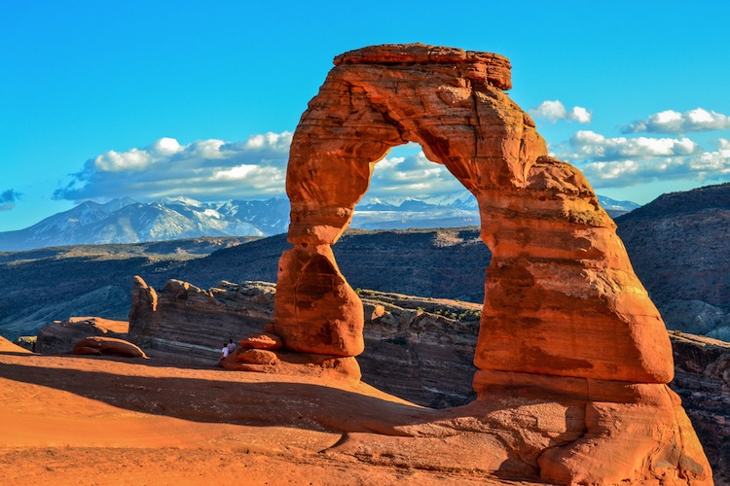
DON”T MISS IT THERE IS A WRESTLING CAMP IN BEAUTIFUL MOAB!!

$220 in FREE!! Purler Wrestling DVDSs and it’s only a $99.00 registration fee for the FIRST 30 KIDS TO REGISTER!!!! Yes! That’s right only $99.00 not $200.00 or the $250.00 you’re used to paying and you can thank our sponsors for that!!
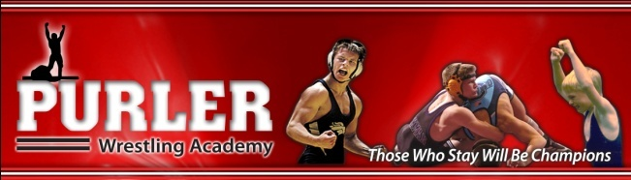

The camp is a Purler Wrestling camp: USA Wrestling National Team Champions / 4X Tulsa National Champions / Over 2,000 State Medalists the list goes on!!! Purler wrestling is a world class group. They are very well respected throughout wrestling communities all over America for their camps!!

Dates - November 17^{th,} 18th and 19th Location - Grand County High School

Session Times – Nov 17th 6-9 pm Nov 18th and 19th 9:00 – 11:45 am / Lunch / 12:30 pm – 2:45 pm / Break / 3:00pm -4:00 pm

Registration – Register online at trackwrestling.com / click on browse and select tournaments and then search for devils wrestling camp if you have questions email moabdevilswrestling@gmail.com or contact Coach Bosh (435-260-0934)

Registration Fee- $99 for the first 30 wrestlers and free DVDs!!! (Enter first30 under coupon only 30 discounts are allowed) $130 for the following 30 wrestlers!! Hurry and sign up limited entry so don’t miss out on this camp. It is predicted to fill up fast Wrestling and Vacation together can’t beat that!

Hotel- Moab is a world class destination for tourism so we highly recommend reserving your rooms ASAP. Aarchway Inn has given the camp nice rooms at a discounted rate $69.00 plus tax which is a great rate for Moab. Tell them you are with Devils Wrestling Camp when you call to receive the special rate.

For questions – please call Coach Bosh/Coach Wright or email moabdevilswrestling@gmail.com. The camp is a Purler Wrestling Academy SYSTEM camp, but is offered by Coach Bosh therefore, all questions should be directed towards him. USA Cards required or you must provide proof of insurance and fill out required forms.

Some concession will be offered please pack a lunch unless you will be taking your wrestler out to eat

Our Sponsors-
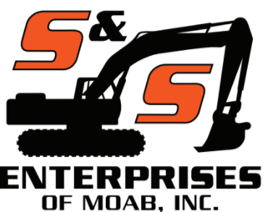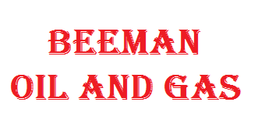

Moab Chevron Zax Pizza

Beeman Drilling / Aarchway Inn / Moab Dinner
Canyonland Auto / 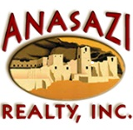 / Grand Tire Pros
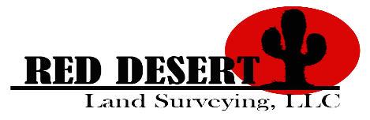 / Moab Maverik /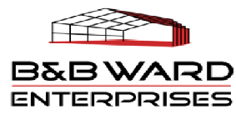
Henderson Builders / Lisbon Valley Mining

