PCJWL DIVISION B CHAMPIONSHIP
SATURDAY JANUARY 19th, 2018
BETHEL HIGH SCHOOL
22215 38TH AVE E
SPANAWAY, WA 98387

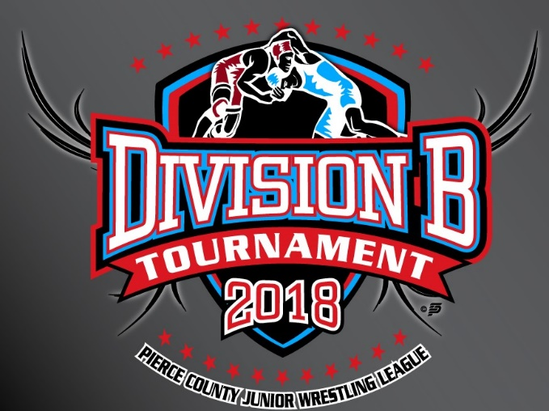

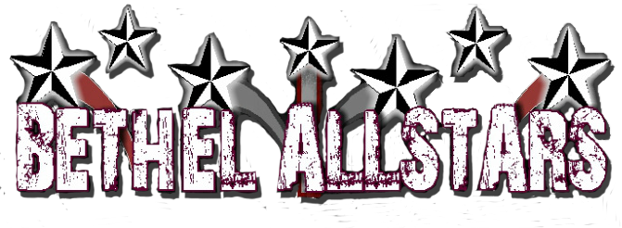
WELCOMES UNIVERSITY PLACE, MONTESANO, EATONVILLE, FEDERAL WAY, OLYMPIA, YELM, ENUMCLAW, AUBURN & GIG HARBOR!

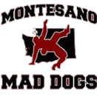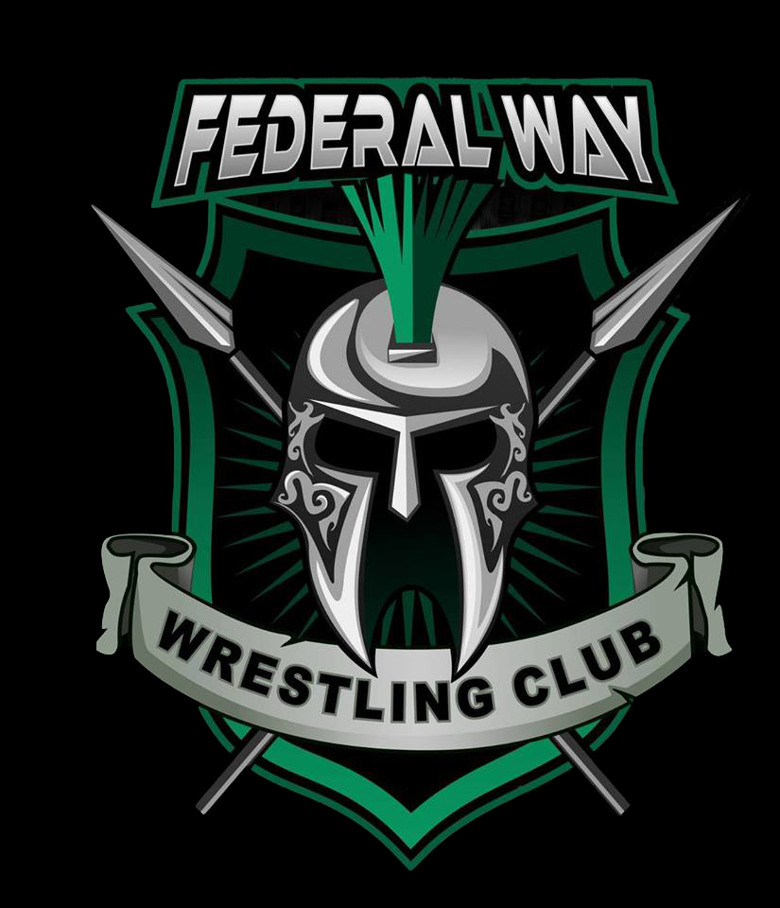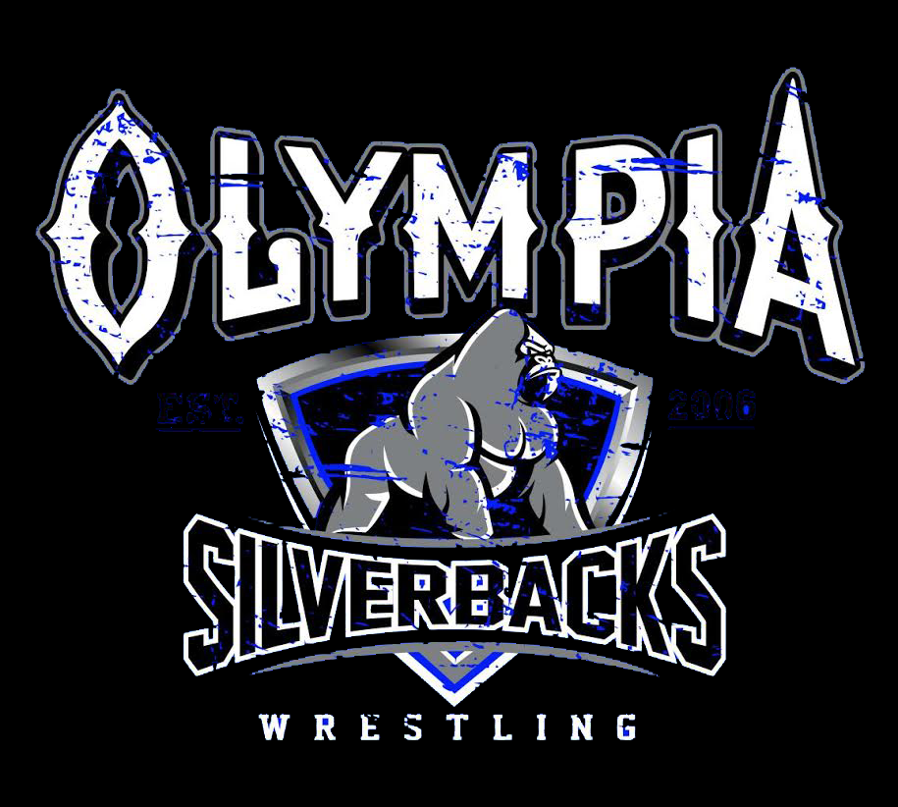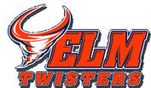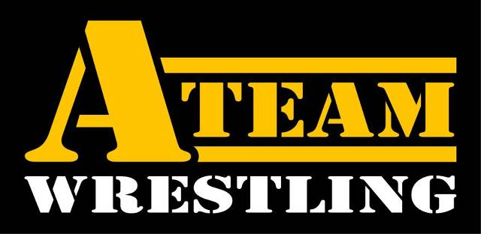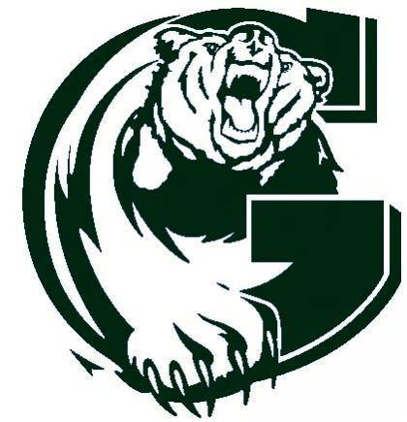

Weigh ins: 7-8:30am Spectator Fees: $5 18+
Wrestling starts: 10am Wrestler fees: $20 - teams responsible for collecting money & paying tournament fees.

WE WILL HAVE A SHORTAGE OF REFEREES! All teams are responsible for providing one referee and table help to rotate throughout the day.
Medals for 1st-5th, ribbons for 6th. Please stay for medals. Top 4 advance to League!

Concessions & t-shirts available all day (pancakes & sausage for breakfast, pizza for lunch)
No tobacco or alcohol on school property!

