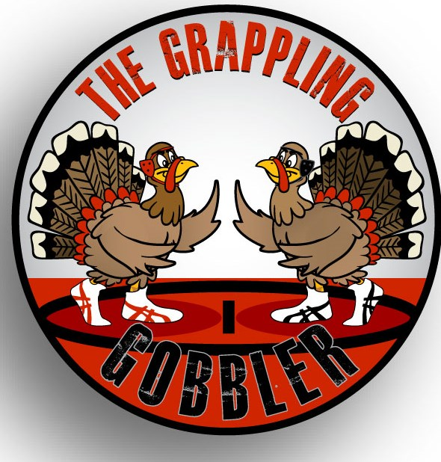
THE GRAPPLING GOBBLER

Saturday, November 24, 2018
Roosevelt High School
(616. N 2nd Street, Johnstown, CO)

Registration: $20.00
Register Online ONLY at www.trackwrestling.com
Deadline: Friday, November 23, at 4:00 pm
Weigh Ins:
This tournament will not have a weigh-in. It is being done on the honor system. Actual weights will be entered during registration. A check scale will be available if there is a weight protest. Wrestlers will be given a 2-pound allowance on tournament day.

Wrestling Begins at: 9:00am
(Doors open at 8:00am / Concessions open at 8:00am)
Admission: $5.00
Under 5 is FREE

Ages determined as of 09/01/2018
4 & Under, 6 & Under, 8 & Under, 10 & Under, 12 & Under, and 15 & Under
NO HIGH SCHOOL WRESTLERS
General Information:
- Weight Classes are Madison block bracketing with brackets up to 6-man round robins.
- We reserve the right to combine age/weight brackets
- Custom medals awarded for 1st thru 3rd place.
- Double-bracketing permitted across age groups.
- NO REFUNDS
Wrestling Periods:
- Age Groups 4, 6 & 8: 1-1-1
- Age Groups 10, 12 & 15: 1.5-1.5-1.5
For more information please email: roughrideryouthwrestling@gmail.com
or contact
Josh Robinson (970) 380-5559.
Sponsored by Rough Rider Youth Wrestling & Roosevelt High School Wrestling

