**[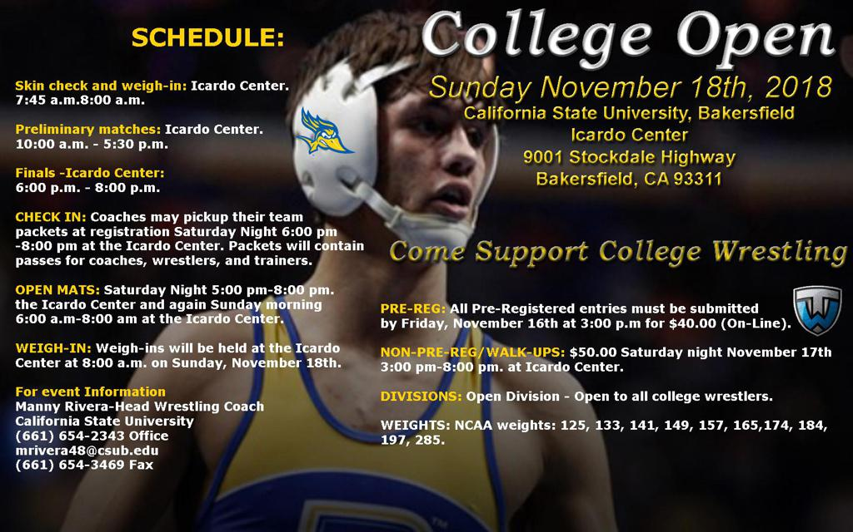](http://www.ca-usaw.org/page/show/1268167-4-year-programs)**