Fleming Island HS IOF

“I Own Florida”

AAU Wrestling
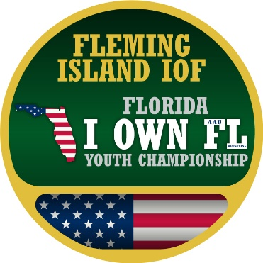
DATES: January 19th, 2019
LOCATION: Fleming Island High School
2233 Village Square Pkwy, Fleming Island, FL 32003
HOST: email: flemingislandwrestling@gmail.com
ENTRY FEE: Pre-register Discount $20 Late (onsite) Registration $30 Addt’l Entries: $20
WEIGH-INS: 8am-9am
REGISTRATION:
Pre-Registration Link:
http://www.trackwrestling.com/registration/BasicPreReg1.jsp?tournamentGroupId=79970132

AAU 2018-2019 “IOF” Age Divisions & Weight Classes:
- Kindergarten and 1st Grade: 42, 46, 51, 56, 62, 75, HWT (no more than 15 lbs difference)
- 2nd and 3rd Grade: 46, 51, 56, 62, 68, 75, 85, 95, HWT (Max 150)
- 4th and 5th Grade: 60, 65, 70, 75, 80, 85, 92, 100, 110, 120, 130, HWT (Max 220)
- Middle School: 70, 75, 80, 85, 90, 95, 102, 110, 117, 125, 135, 145, 160, 180, HWT (Max 265)
- Tournament directors may combine or modify weight classes: giving kids matches for experience.

For information on weigh-in and start times, directions to tournaments, and other general information on each event contact the specific event directors.
This event is licensed by the Amateur Athletic Union of the U.S.,Inc.
- All participants must have a current AAU membership.
-AAU membership may not be included as part of the entry fee to the event.
-AAU Youth Athlete membership must be obtained before the competition begins.
-BE PREPARED! Adult and Non Athlete memberships are no longer instant and cannot be applied for at event.
-Please allow at least 10 days for membership to be processed.
-Participants are encouraged to visit the AAU website www.aausports.org to obtain their membership.

FOR MORE INFORMATION: flemingislandwrestling@gmail.com

