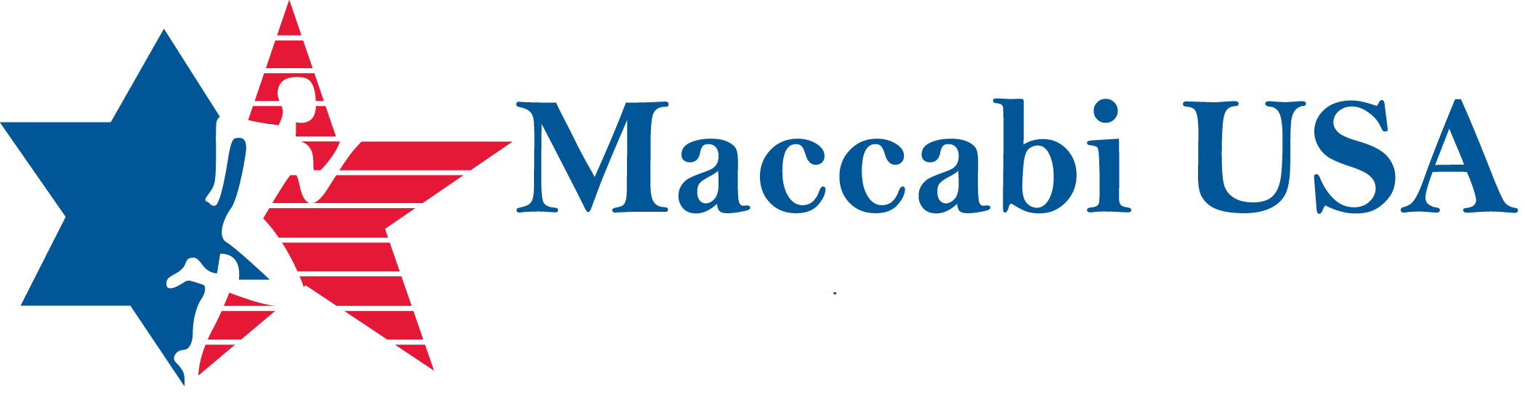
  - Maccabi UWW Junior National Freestyle and Jim Davey L.I. Junior Open Freestyle, Greco & Girls Championships
Age Divisions | Weight Classes
UWW Junior Men Free | 57 /125.7, 61/134/5, 65/143.3, 70/154.3, 74/163, 79/174.2, 86/189.6, 92/202.8, 97/213.8, 125/275.6  (Bold #s are in KG)  Open to High Schoolers (grades 9-12) as of 9/30/18 and appropriate aged college athletes.
USAW Junior Boys Free | 100, 106, 113, 120, 126, 132, 138, 145, 160, 170, 182, 195, 220, 285  Open to High Schoolers (grade 9-12) as of 9/30/18.
USAW Junior Boys Greco | 100, 106, 113, 120, 126, 132, 138, 145, 160, 170, 182, 195, 220, 285  Open to High Schoolers (grade 9-12) as of 9/30/18.
USAW Junior Girls | 100, 106, 112, 117, 122, 127, 132, 138, 144, 152, 164, 180, 200, 225  Open to High Schoolers (grades 9-12) as of 9/30/18.

Must have a current USAW Membership Card. $50 to enter one and $10 for every other tournament you want to wrestle in.
Date: Sunday, September 30, 2018
Time: Weigh-Ins 7:00 – 8:00 AM
Wrestling Starts at approximately 9:00 AM - 5:00 PM
Location: LIU Post
720 Northern Blvd.
Old Brookville, NY 11548

Registration: website link - https://www.maccabiusa.com/
Go bottom of page under Events and click ‘Register Here’

