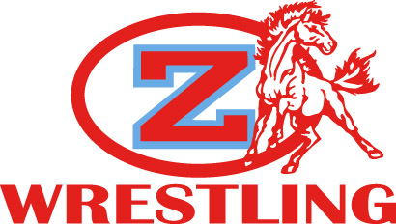

Kickoff at the Corral
LHSAA 9th Grade and JV

Location: Zachary High School
4100 Bronco Lane
Zachary, La.

Date: Saturday; November 10th, 2017

Entry Fee: $10 per wrestler

Entry Deadline: Entries should be entered on TrackWrestling by 7 pm on Thursday, November 9th.
All changes after that point must be sent in by email to
jeanpaul.pierre@zacharyschools.org. Any wrestler not removed from the bracket by
Friday must be paid for on Saturday.

Weigh-Ins: 8 am

Wrestling: 9:30 to completion

Awards: 1st-3rd place medals

