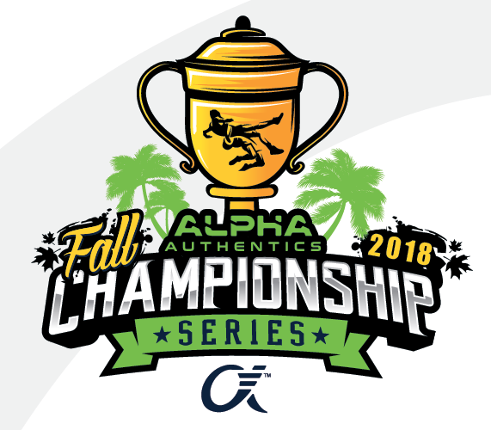
Wellington Alpha Authentics Qualifier

Saturday, September 8th 2018
Entry Fee: $20 if pre-registered
$25 register at the door
($15 second entry, $10 third entry)

Need AAU CARD!

Wellington High School Gym
2101 Greenview Shores Blvd.
Wellington, FL 33414

K-8th Grades
Weigh-in 7:00-8:00 am
Wrestling 8:45 am

High School Division (Varsity & JV)
Weigh-ins – 9:00-10:00 am
Wrestling – 10:45 am

Awards for 1st-3rd places

Pre-register at:

http://www.trackwrestling.com/registration/BasicPreReg1.jsp?tournamentGroupId=66183132

Email with questions: travis.gray@palmbeachschools.org

- This event is licensed by the Amateur Athletic Union of the U.S., Inc.
- All participants must have a current AAU membership.
- AAU membership may not be included as part of the entry fee to the event.
- AAU Youth Athlete membership must be obtained before the competition begins, except where the event operator has a laptop available with an internet connection.
Be Prepared: Adult and Non-Athlete memberships are no longer instant and cannot be applied for at an event.
Due to background screenings, please allow up to 10 days for adult memberships to be processed.
- Participants are encouraged to visit the AAU website www.aausports.org to obtain their membership.

