Tournament Rules
Boys: FOLKSTYLE
Girls: FREESTYLE
- Top 4 Boys get early registration for Super 32 in Greensboro, N.C
- Double Elimination, Wrestle back to 4th place
- Boys: Periods 2 – 1 – 1. Wrestle-backs 1 – 1 – 1
- Girls: Periods 2 - 2
- Top 3 Medal
- Seeds are blind draw. Attempt will be made to separate national/state place winners
- High School weights + 3
- College out of bounds rules
- Old School OT rules. 1 One Minute period then 1- 30 second ride out
- High School Division weight classes, 7th and 8th graders may register
- Expect large brackets, minimum 20-minute rest between matches
- Wrestling on 5 Mats
- Certified Officials will be used
- Missed weight is $15 fee for bracket change

ADMISSION: $10 Adults $5 Students

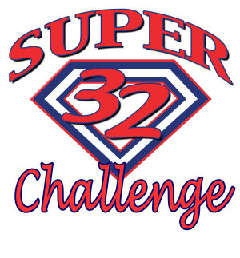
Super 32 Road to the Belt
Early Entry Tournament
*Early entry for boys only*
Presented by Clear Springs High School Booster Club
BOYS Super 32 Early Entry Tournament
GIRLS Freestyle Tournament
SATURDAY SEPTEMBER 8TH
Clear Springs High School
501 Palomino Ln
League City, TX 77573

BOYS FOLKSTYLE WEIGHTS: 106, 113, 120, 126, 132, 138, 145, 152, 160, 170, 182, 195, 220, 285

GIRLS FREESTYLE WEIGHTS: 95, 102, 110, 119, 128, 138, 148, 165, 185, 215

ALL WEIGHTS ARE +3

Weigh-ins @ Clear Springs High School
Friday September 7th^{th} 6pm – 9pm
Saturday September 8th 6am – 8am

Wrestling will start at 9am

Registration
Boys: $32 online trackwrestling before September 6th midnight $42 onsite
Girls: $20 online trackwrestling before September 6th midnight $30 onsite
*Missed weight $15 fee for bracket change

Top 4 BOYS get early entry to Super 32 Tournament
Greensboro Coliseum Special Events Center
October 27th – 28th Greensboro, North Carolina

Tournament Contacts: Mike Jimenez: mjimenez@ccisd.net Cell: 516-680-0689

Chris Reed: chreed@ccisd.net Cell: 832-265-9024

